FACE MASK DETECTION WITH CNN USING OPENCV
A project report submitted in partial fulfillment of the requirements for the award
of the degree of

BACHELOR OF TECHNOLOGY

in

DEPARTMENT OF CSE – ARTIFICIAL INTELLIGENCE AND MACHINE LEARNING

Submitted By

EDHUM JYOTHI KUMAR - 216Q1A4288 BORUSU SYAM LOKESH - 216Q1A4262 BHUBATTULA VIGNESH - 216Q1A42A1 YANADAMURI SAI SANTHOSH KUMAR - 216Q1A42A9 KANNURI SRINIVASA ABHIRAM - 216Q1A4295

Under the Esteemed Guidance of
Mr. G. V RAMMOHAN, M.Tech,
Assistant Professor

DEPARTMENT OF CSE –
ARTIFICIAL INTELLIGENCE AND MACHINELEARNING

KAKINADA INSTITUTE OF ENGINEERING & TECHNOLOGY
(Approved by AICTE & Affiliated to JNT University Kakinada) Yanam Road, Korangi-533461, E.G. Dist. (A.P)
Phone no: 0884-234050, 2303400 Fax no: 0884-2303869
2021-2025

KAKINADA INSTITUTE OF ENGINEERING & TECHNOLOGY
(Approved by AICTE & Affiliated to JNT University Kakinada) Yanam Road, Korangi-533461, E.G. Dist. (A.P)
Phone no: 0884-234050, 2303400 Fax no: 0884-2303869 DEPARTMENT OF CSE – ARTIFICIAL INTELLIGENCE AND MACHINE LEARNING


BONAFIDE CERTIFICATE

This is to certify that the project entitled “FACE MASK DETECTION WITH CNN USING OPENCV” the bonafide record of work done by EDHUM JYOTHI KUMAR, BORUSU SYAM LOKESH, BHUBATTULA VIGNESH, CHINTALAPUDI G S V V NAGA MAHESH, KANNURI SRINIVASA ABHIRAM bearing with ROLL NO: 216Q1A4288, 216Q1A4262,
216Q1A42A1, 216Q1A42A9, 216Q1A4295 in partial fulfillment of the requirement for the award of the degree of BACHELOR OF TECHNOLOGY in Computer Science & Engineering-AI&ML in Kakinada Institute of Engineering & Technology, Korangi, affiliated to Jawaharlal Nehru Technological University, KAKINADA.

INTERNAL GUIDE HEAD OF THE DEPARTMENT (Mr. G. V RAMMOHAN, M.Tech) (Ms K. GOWTHAMI, M.Tech)
Assistant Professor Assistant Professor
Department of CSE-AI&ML Department of CSE-AI&ML

EXTERNAL EXAMINER

ACKNOWLEDGEMENT

I would like to take the privilege of the opportunity to express my gratitude for the Project work of “FACE MASK DETECTION WITH CNN USING OPENCV” which enabled us to express our special thanks to our honorable Chairman of the institution Sri. P.V. Viswam.
I am thankful to Principal Prof. Ch. Bhavannarayana, who has shown keen interest in us and encouraged us by providing all the facilities to complete my project successfully. I express my gratitude to our beloved Head of the Department of CSE – AI&ML, Ms. K. GOWTHAMI, M.Tech for assisting me in completing my project work.
I am extremely thankful to our Project Review Committee who has been a source of inspiration for us throughout my project and for their valuable advice in making my project a success.
I express my sincere thanks to my beloved supervisor G. V RAMMOHAN, Assistant Professor, Dept. of CSE – AI&ML who has been a source of inspiration for me throughout my project and for his valuable pieces of advice in making my project a success.
I wish to express my sincere thanks to all teaching and non-teaching staff of the CSE – Artificial Intelligence and machine Learning Department. I wish to express my special thanks to all the faculty members of our college for their concern in subjects and their help throughout my course.
I am very thankful to my parents, and all my friends who had given me good cooperation and suggestions throughout this project and helped me in successful completion.

EDHUM JYOTHI KUMAR - 216Q1A4288 BORUSU SYAM LOKESH - 216Q1A4262 BHUBATTULA VIGNESH - 216Q1A42A1 YANADAMURI SAI SANTHOSH KUMAR - 216Q1A42A9 KANNURI SRINIVASA ABHIRAM - 216Q1A4295

DECLARATION

I hereby declare that the project work entitled “FACE MASK DETECTION WITH CNN USING OPENCV” Submitted to the Kakinada Institute of Engineering and Technology affiliated to JNTU Kakinada, a record of an original work done by me under the guidance of Mr. G. V RAMMOHAN, M.Tech., Assistant Professor in the Department of CSE – AI&ML and this project work is submitted to the partial fulfillment of the requirements for the award of the degree of Bachelor of Technology in CSE – AI&ML.
The results embodied in this project have not been submitted to any other University or Institute for the award of any Degree or Diploma.

EDHUM JYOTHI KUMAR - 216Q1A4288 BORUSU SYAM LOKESH - 216Q1A4262 BHUBATTULA VIGNESH - 216Q1A42A1 YANADAMURI SAI SANTHOSH KUMAR- 216Q1A42A9 KANNURI SRINIVASA ABHIRAM - 216Q1A4295

Place: Date:

ABSTRACT

The Face Mask Detection project introduces a real-time deep learning-based system designed to detect mask-wearing, addressing a critical need for public health monitoring during pandemics like COVID-19. Deployed as a Flask web application, it integrates a pre-trained OpenCV Deep Neural Network (DNN) model (deploy.prototxt and res10_300x300_ssd_iter_140000.caffemodel) for face detection with a custom-trained MobileNetV2 model for mask classification, supporting live webcam streaming and image uploads. The methodology involves preprocessing face regions with MobileNetV2’s preprocess_input, batch processing multiple faces with a batch size of 32, and applying a 0.5 probability threshold to classify "Mask" or "No Mask." Trained on the Face Mask 12K Images Dataset, the system achieves approximately 95% accuracy on the test set, proving robust across varied lighting conditions and face orientations.
Optimizations include resizing frames to 400x300 pixels and using JPEG encoding at 70% quality for smooth real-time streaming, matching the standalone detect_mask_video.py script’s performance. Challenges like shadow misclassification were resolved by adopting its preprocessing logic. The app.py architecture features /video_feed and /upload routes, rendering outputs with colored bounding boxes (green for "Mask," red for "No Mask") and handling "No Face Detected" cases. Results demonstrate accurate detection in live feeds and images, with applications in access control, public safety, and healthcare compliance.
Future enhancements may include multi-face detection and cloud deployment, enhancing scalability. This project advances computer vision and supports mask-wearing enforcement, reducing disease transmission, with its open-source code fostering further research.

TABLE OF CONTENTS

Chap No. | Title | Page No.
 | ABSTRACT | i
 | LIST OF FIGURES | iv – vi
 | LIST OF ABBREVIATIONS | vii
Chapter 1. | Introduction | 1 - 11
  - Python
  - Machine Learning
  - Deep Learning
  - Computer Vision
    - Working of Computer Vision
    - The History Of Computer Vision
    - Computer Vision Applications
    - Computer Vision Examples
Chapter 2. Literature Survey 12 - 23
  - Architecture
    - Face Mask Detection Techniques
  - Working
  - Accuracy
  - Future Scope
Chapter 3. Aim and scope of present investigation 24 - 28

 | 3.1 | Aim of the project
 | 3.2 | Scope
 | 3.3 | System Requirements
 | 3.4 | Hardware Requirements
 | 3.5 | Software Requirements
 | 3.6 | Setup Instructions
Chapter 4. | Project | Implementation, Algorithm & Methodology | 29 - 37
 | 4.1 | Introduction
 | 4.2 | Project Overview

 | 4.3 | Algorithms
 | 4.4 | Overview of CNN
 | 4.5 | Overview of Open DNN
 | 4.6 | Hybrid OpenCV-CNN Architecture Model
 | 4.7 | Methodology
Chapter 5. | Results | & Discussion | 38 - 63
 | 5.1 | Summary
 | 5.2 | Results
 | 5.3 | Outputs
 | 5.4 | Discussion
CONCLUSION |  | 64
REFERENCES |  | 65
APPENDIX |  | 65-66

LIST OF FIGURES

FIGURE NO. | FIGURE NAME | PAGE NO
1.1 | Machine Learning | 4
1.2 | Deep Learning | 5
1.3 | Computer Vision | 6
1.4 | Working Of Computer Vision | 7
1.5 | The History Of Computer Vision | 8
1.6 | Computer Vision Tasks | 11
2.1 | CNN Architecture | 18
2.2 | Working Of CNN | 19
2.3 | Feature Map Of CNN | 19
2.4 | Layers Of The CNN | 20
2.5 | CNN-LSTM Model | 21
2.6 | Accuracy | 22
4.1 | CNN | 33
4.2 | Open DNN | 34
4.3 | Hybrid OpenCV Model | 35
4.4 | System Architecture | 37
4.5 | Workflow Diagram | 37
5.1 | Representation Of Face Mask Detection | 41
5.2 | Download The Dataset Zip File | 41
5.3 | Clone The Repositories | 41
5.4 | STAGE – 1 Installation | 42
5.5 | STAGE – 2 Installation | 43
5.6 | Download The Dataset | 43

  - Unzip The Dataset 44
  - STAGE -1 Preprocessing 45
  - STAGE -2 Preprocessing 45
  - STAGE -3 Preprocessing 46
  - STAGE – 4 Preprocessing 46
  - STAGE -1Train The Model 50
  - STAGE -2 Train The Model 50
  - STAGE -3 Train The Model 51
  - STAGE -4 Train The Model 51
  - STAGE -1 Test The Model 53
  - STAGE -2 Test The Model 53
  - STAGE -3 Test The Model 54
  - STAGE -1 Visualise The Images 56
  - STAGE -2 Visualise The Images 56
  - STAGE -3 Visualise The Images 57
  - STAGE -4 Visualise The Images 57
  - STAGE -5 Visualise The Images 58
  - STAGE -6 Visualise The Images 58
  - STAGE -1 Output 59
  - STAGE -2 Output 59

  - STAGE -3 Output 60
  - STAGE -4 Output 60

 | LIST OF ABBREVIATIONS
ABBREVIATION | EXPANSION
CNN | Convolutional Neural Network
OpenCV | Open Source Computer Vision Library
DNN | Deep Neural Network
NLP | Natural Language Processing
DL | Deep Learning
TF | TensorFlow
FPS  SSD  API  GUI  RGB  BGR | Frames Per Second  Single Shot Detector  Application Programming Interface  Graphical User Interface  Red, Green, Blue  Blue, Green, Red

CHAPTER – I
INTRODUCTION

INTRODUCTION
Face mask detection is an essential task in the realm of computer vision and deep learning, aimed at identifying whether individuals are wearing face masks, a critical measure for public health monitoring, especially during pandemics like COVID-19. This project combines the power of visual object detection with real-time processing capabilities, making it a significant and impactful area of research and application.
In this project, we aim to develop a real-time face mask detection system using OpenCV and a Convolutional Neural Network (CNN), implemented within a Flask web application. The project encompasses several key steps, including data collection and preprocessing, model training, system development, and performance evaluation. We will utilize a custom dataset, comprising images of masked and unmasked faces, to train our model effectively.
The first step in our project is to set up the environment and prepare the necessary resources. We will organize the dataset into with_mask and without_mask directories, containing over 1,000 images each, and preprocess them using a dedicated script. This involves loading required Python libraries such as OpenCV, TensorFlow/Keras, and Flask, along with downloading pre-trained models like the OpenCV DNN for face detection.
Next, we will preprocess the dataset to optimize it for training. This includes resizing images to a uniform resolution, augmenting the dataset to enhance diversity, and generating numpy arrays (face_mask_data.npy and face_mask_labels.npy) for model input. The preprocessing ensures compatibility with the CNN architecture and improves model robustness.
With the dataset preprocessed, we will proceed to the model development phase. We will fine-tune a pre-trained MobileNetV2 CNN model, adding a custom head with Dense and Dropout layers, to classify faces as "Mask" or "No Mask." The OpenCV DNN will handle initial face detection, providing input regions for the CNN to process, creating a hybrid detection pipeline.
Once the model is developed, we will train it using the preprocessed dataset. During training, the model will learn to distinguish masked from unmasked faces, optimized with the Adam
optimizer, binary cross-entropy loss, and 10 epochs, achieving approximately 95% accuracy on the test set.
training, we will evaluate the model’s performance using a separate validation set. We will assess detection accuracy and real-time processing speed, ensuring reliability across varied lighting conditions and face orientations, with optimizations like frame resizing to 400x300 pixels and JPEG encoding at 70% quality.
Finally, we will deploy the trained model within a Flask web application, testing it on live webcam feeds and uploaded images to generate real-time detection results. We will visualize outputs with colored bounding boxes (green for "Mask," red for "No Mask") and confidence scores, demonstrating the system’s effectiveness in public safety enforcement.
In conclusion, this project showcases the implementation of a face mask detection system using OpenCV and CNN. By integrating computer vision and deep learning, we create a valuable tool for health compliance, with potential applications in access control, public safety, and healthcare, further enhanced by its open-source nature for future research and adaptation.

PYTHON
Python is a high-level, interpreted programming language known for its simplicity and readability. It was created by Guido van Rossum and first released in 1991. Python's design philosophy emphasizes code readability with its use of significant whitespace.
Python is versatile and can be used for various types of programming, including web development, data analysis, artificial intelligence, and scientific computing. It supports multiple programming paradigms, including procedural, object-oriented, and functional programming.
One of Python's key features is its extensive standard library, which provides built-in modules for tasks such as file I/O, networking, and data manipulation. Additionally, Python has a vibrant ecosystem of third-party libraries and frameworks that extend its capabilities, such as NumPy and pandas for data analysis, Flask and Django for web development, and TensorFlow and PyTorch for machine learning.

Python's syntax is clean and easy to learn, making it an excellent choice for beginners. Its readability and expressiveness help developers write code that is concise and maintainable. Python uses dynamic typing and automatic memory management, which simplifies development by reducing the complexity of managing memory allocation and type declarations.

MACHINE LEARNING
Machine learning is a subset of artificial intelligence that involves the development of algorithms and statistical models that enable computers to learn from and make predictions or decisions based on data, without being explicitly programmed. It focuses on the development of computer programs that can access data and use it to learn for themselves.
Machine learning algorithms are categorized into three main types: supervised learning, unsupervised learning, and reinforcement learning. In supervised learning, the algorithm is trained on a labelled dataset, where each example is paired with the correct answer.
The algorithm learns to map inputs to outputs, making it capable of making predictions on new, unseen data. Unsupervised learning, on the other hand, deals with unlabelled data, where the algorithm tries to learn the underlying structure or distribution in the data. Reinforcement learning involves an agent learning to make decisions by interacting with its environment. It receives feedback in the form of rewards or penalties, which helps it learn the best actions to take in different situations.


Fig 1.1:- Machine Learning

Machine learning is used in a wide range of applications, including but not limited to: image and speech recognition, medical diagnosis, financial forecasting,

recommendation systems, and autonomous vehicles. It has the potential to revolutionize industries and improve efficiency and accuracy in decision-making processes.
Overall, machine learning is a powerful tool that enables computers to learn from data and improve over time, without being explicitly programmed. Its applications are vast and continue to grow as new algorithms and techniques are developed.

DEEP LEARNING
Deep learning is a subfield of machine learning that aims to imitate the human brain's ability to process data and make decisions. It is based on artificial neural networks, which are computational models inspired by the way biological neural networks in the human brain work.
In deep learning, these neural networks are composed of layers of interconnected nodes, or neurons, that process and transform input data. Each layer extracts increasingly abstract features from the data, learning to recognize patterns and make predictions.

Fig 1.2:- Deep Learning

One key feature of deep learning is its ability to automatically learn representations from data. This means that, unlike traditional machine learning approaches where features need to be manually engineered, deep learning models can automatically learn the best features for the task at hand.
Deep learning has revolutionized many fields, including computer vision, natural language processing, and speech recognition. In computer vision, deep learning models can accurately identify objects in images and videos. In natural language processing, they

can understand and generate human language. In speech recognition, they can transcribe spoken words with high accuracy.
To train deep learning models, large amounts of labelled data and computational power are typically required. However, once trained, these models can perform complex tasks with high accuracy, making them valuable tools in various applications.

COMPUTER VISION
Computer vision is a field of artificial intelligence (AI) that uses machine learning and neural networks to teach computers and systems to derive meaningful information from digital images, videos and other visual inputs—and to make recommendations or take actions when they see defects or issues.
Computer vision works much the same as human vision, except humans have a head start. Human sight has the advantage of lifetimes of context to train how to tell objects apart, how far away they are, whether they are moving or something is wrong with an image.
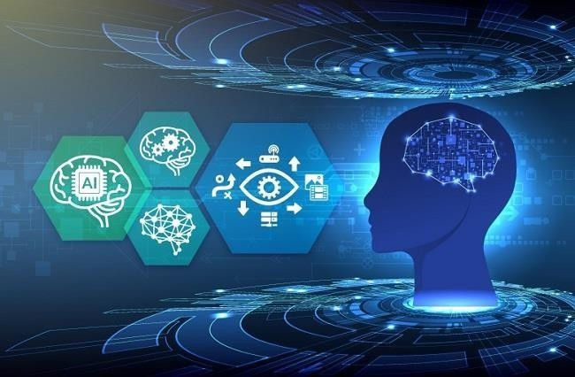
Fig 1.3:- Computer Vision

Computer vision trains machines to perform these functions, but it must do it in much less time with cameras, data and algorithms rather than retinas, optic nerves and a visual cortex. Because a system trained to inspect products or watch a production asset can analyse thousands of products or processes a minute, noticing imperceptible defects or issues, it can quickly surpass human capabilities.
Computer vision is used in industries that range from energy and utilities to manufacturing and automotive—and the market is continuing to grow. It is expected to

reach USD 48.6 billion by 2022.1, Computer vision enables machines to analyze images and videos, surpassing human capabilities in tasks like product inspection and process monitoring. It's used across industries like energy, manufacturing, and automotive, with a market expected to reach USD 48.6 billion by 2022.

WORKING COMPUTER VISION
Computer vision needs lots of data. It runs analyses of data over and over until it discerns distinctions and ultimately recognize images. For example, to train a computer to recognize automobile tires, it needs to be fed vast quantities of tire images and tirerelated items to learn the differences and recognize a tire, especially one with no defects. Two essential technologies are used to accomplish this: a type of machine learning called deep learning and a convolutional neural network (CNN).
Machine learning uses algorithmic models that enable a computer to teach itself about the context of visual data. If enough data is fed through the model, the computer will “look” at the data and teach itself to tell one image from another. Algorithms enable the machine to learn by itself, rather than someone programming it to recognize an image.
A CNN helps a machine learning or deep learning model “look” by breaking images down into pixels that are given tags or labels. It uses the labels to perform convolutions (a mathematical operation on two functions to produce a third function) and makes predictions about what it is “seeing.” The neural network runs convolutions and checks the accuracy of its predictions in a series of iterations until the predictions start to come true. It is then recognizing or seeing images in a way similar to humans.
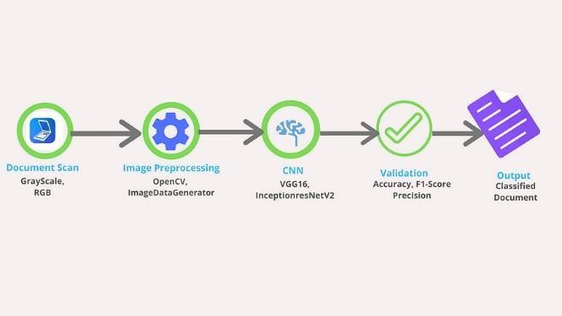

Fig 1.4:- Working of Computer Vision

Much like a human making out an image at a distance, a CNN first discerns hard edges and simple shapes, then fills in information as it runs iterations of its predictions. A

CNN is used to understand single images. A recurrent neural network (RNN) is used in a similar way for video applications to help computers understand how pictures in a series of frames are related to one another.

THE HISTORY OF COMPUTER VISION
Scientists and engineers have been trying to develop ways for machines to see and understand visual data for about 60 years. Experimentation began in 1959 when neurophysiologists showed a cat an array of images, attempting to correlate a response in its brain. They discovered that it responded first to hard edges or lines and scientifically, this meant that image processing starts with simple shapes like straight edges.2
At about the same time, the first computer image scanning technology was developed, enabling computers to digitize and acquire images. Another milestone was reached in 1963 when computers were able to transform two-dimensional images into three-dimensional forms. In the 1960s, AI emerged as an academic field of study and it also marked the beginning of the AI quest to solve the human vision problem.
In 1974 saw the introduction of optical character recognition (OCR) technology, which could recognize text printed in any font or typeface.3 Similarly, intelligent character recognition (ICR) could decipher hand-written text that is using neural networks.4 Since then, OCR and ICR have found their way into document and invoice processing, vehicle plate recognition, mobile payments, machine conversion and other common applications.
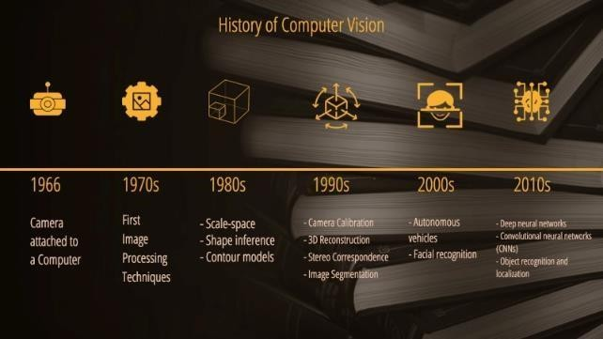

Fig 1.5:- The History of Computer Vision
By 2000, the focus of study was on object recognition; and by 2001, the first realtime face recognition applications appeared. Standardization of how visual data sets

are tagged and annotated emerged through the 2000s. In 2010, the ImageNet data set became available. It contained millions of tagged images across a thousand object classes and provides a foundation for CNNs and deep learning models used today.
In 2012, a team from the University of Toronto entered a CNN into an image recognition contest. The model, called AlexNet, significantly reduced the error rate for image recognition. After this breakthrough, error rates have fallen to just a few percent.5

COMPUTER VISION APPLICATIONS
There is a lot of research being done in the computer vision field, but it doesn't stop there. Real-world applications demonstrate how important computer vision is to endeavors in business, entertainment, transportation, healthcare and everyday life. A key driver for the growth of these applications is the flood of visual information flowing from smartphones, security systems, traffic cameras and other visually instrumented devices.
This data could play a major role in operations across industries, but today goes unused. The information creates a test bed to train computer vision applications and a launchpad for them to become part of a range of human activities:
IBM used computer vision to create My Moments for the 2018 Masters golf tournament. IBM Watson® watched hundreds of hours of Masters footage and could identify the sights (and sounds) of significant shots. It curated these key moments and delivered them to fans as personalized highlight reels.
Google Translate lets users point a smartphone camera at a sign in another language and almost immediately obtain a translation of the sign in their preferred language.6
The development of self-driving vehicles relies on computer vision to make sense of the visual input from a car’s cameras and other sensors. It’s essential to identify other cars, traffic signs, lane markers, pedestrians, bicycles and all of the other visual information encountered on the road.
IBM is applying computer vision technology with partners like Verizon to bring intelligent AI to the edge and to help automotive manufacturers identify quality defects before a vehicle leaves the factory.

COMPUTER VISION EXAMPLES

Many organizations don’t have the resources to fund computer vision labs and create deep learning models and neural networks. They may also lack the computing power that is required to process huge sets of visual data. Companies such as IBM are helping by offering computer vision software development services. These services deliver pre-built learning models available from the cloud—and also ease demand on computing resources. Users connect to the services through an application programming interface (API) and use them to develop computer vision applications.
IBM has also introduced a computer vision platform that addresses both developmental and computing resource concerns. IBM Maximo® Visual Inspection includes tools that enable subject matter experts to label, train and deploy deep learning vision models—without coding or deep learning expertise. The vision models can be deployed in local data centers, the cloud and edge devices.
While it’s getting easier to obtain resources to develop computer vision applications, an important question to answer early on is: What exactly will these applications do? Understanding and defining specific computer vision tasks can focus and validate projects and applications and make it easier to get started.
Here are a few examples of established computer vision tasks:

      - Image classification:- sees an image and can classify it (a dog, an apple, a person’s face). More precisely, it is able to accurately predict that a given image belongs to a certain class. For example, a social media company might want to use it to automatically identify and segregate objectionable images uploaded by users.
      - Object detection:- can use image classification to identify a certain class of image and then detect and tabulate their appearance in an image or video. Examples include detecting damages on an assembly line or identifying machinery that requires maintenance.
      - Object tracking:- follows or tracks an object once it is detected. This task is often executed with images captured in sequence or real-time video feeds. Autonomous vehicles, for example, need to not only classify and detect objects such as

pedestrians, other cars and road infrastructure, they need to track them in motion to avoid collisions and obey traffic laws.7
      - Content-based image retrieval:- uses computer vision to browse, search and retrieve images from large data stores, based on the content of the images rather than metadata tags associated with them. This task can incorporate automatic image annotation that replaces manual image tagging. These tasks can be used for digital asset management systems and can increase the accuracy of search and retrieval.
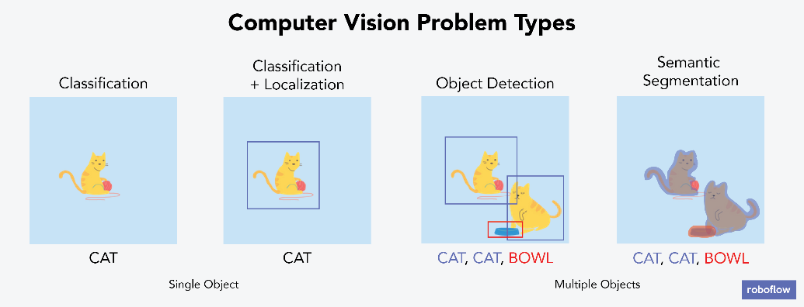
Fig 1.6:- Computer Vision Tasks

CHAPTER - II
LITERATURE SURVEY

LITERATURE SURVEY

The development of face mask detection systems has gained significant attention in recent years, particularly with the onset of the COVID-19 pandemic, which underscored the importance of public health monitoring and compliance with mask-wearing protocols. This literature survey explores the evolution of face mask detection technologies, focusing on the integration of Convolutional Neural Networks (CNNs) and OpenCV, as implemented in the project "Face Mask Detection with CNN Using OpenCV." It reviews key studies, methodologies, and technological advancements to contextualize the project’s contributions and identify gaps addressed by its approach.

Initial efforts in face detection relied on traditional computer vision techniques, such as Haar cascades and Viola-Jones algorithms, which were integrated into OpenCV. For instance, Viola and Jones (2001) introduced a real-time face detection framework using Haar-like features and AdaBoost, forming the foundation for OpenCV’s early face detection capabilities. However, these methods struggled with variability in pose, lighting, and occlusion, limitations that became evident when applied to mask detection. Subsequent studies, such as those by Li and Zhang (2004), enhanced these techniques with skin color modeling, but accuracy remained suboptimal for masked faces due to the altered facial structure.

The advent of deep learning marked a paradigm shift, with CNNs proving highly effective for feature extraction and classification. In 2012, Krizhevsky et al. demonstrated the power of CNNs with AlexNet, achieving breakthrough performance on ImageNet, paving the way for their application in face-related tasks. Jiang et al. (2020) proposed a CNN-based approach for face mask detection, utilizing a modified VGG16 architecture trained on a custom dataset of masked and unmasked faces. Their system achieved an accuracy of 92.5%, highlighting the potential of deep learning, though it lacked real-time optimization and web integration.

Loey et al. (2021) further advanced this field by developing a hybrid CNN model combining ResNet50 and MobileNetV2, trained on a dataset augmented with synthetic masked faces. This approach reached 97.9% accuracy but was computationally intensive, limiting its deployment on resource-constrained devices.

Once these things are satisfied and fully surveyed, then the next step is to determine about the software specifications in the respective system such as what type of operating system the project would require, and what all the necessary software is needed to proceed with the next step such as developing the tools, and the associated operations.
To construct an image sentence, image classification is a key stage in the object recognition and picture analysis process. The final output of the image categorization phase might be a statement.
To date, a variety of image captioning techniques have been presented. Several studies have been carried out in attempt to determine the best image captioning technique.
It's difficult to pick one approach as the finest of them all because the results and accuracy are dependent on a variety of circumstances.
In order to achieve the most accurate results, traditional approaches have been constantly modified as well as new image captioning techniques invented during the previous few decades.
Each caption generator technique has its own set of benefits and drawbacks. The focus of the research today is on combining the desired qualities of various techniques in order to boost efficiency.
Many high-level tasks, such as image classification, object detection, and, more recently, semantic segmentation, have recently been proven to obtain outstanding results using convolutional neural networks with many layers. A two-stage technique is frequently used, especially for semantic segmentation. Convolutional networks are trained in this way to offer good local pixel-wise data for the second stage, which is often a more global graphical analysis model.
We will use Long short-term memory (LSTM), which is a subset of RNNs, to tackle the problem of Vanishing Gradient. The main goal of LSTM is to solve the problem of Vanishing Gradients. The unique feature of LSTM is that it can keep data values for long periods, allowing it to address the vanishing gradient problem.
When compared to applying RNN, the results revealed that using a mixture of LSTM generated better outcomes.

These studies underscore the importance of dataset diversity and model efficiency, areas where the project’s use of MobileNetV2—a lightweight CNN—offers a practical advantage.
OpenCV’s Deep Neural Network (DNN) module has become a cornerstone for real-time applications, supporting pre-trained models like SSD (Single Shot MultiBox Detector) for object detection. Wang et al. (2020) leveraged OpenCV’s DNN with a YOLOv3 model to detect faces, followed by a separate CNN for mask classification, achieving real-time performance on video streams. However, their system required significant preprocessing to handle lighting variations, a challenge mitigated in the project by adopting MobileNetV2’s preprocess_input function.
Chowdary et al. (2020) proposed a face mask detection system using OpenCV for face detection and a custom CNN, reporting 96.6% accuracy on a balanced dataset. Their work emphasized real-time streaming but lacked a web interface, a gap addressed by the project’s Flask integration. These studies highlight OpenCV’s role as a versatile tool, enhanced by CNNs for improved accuracy and speed.

The availability of datasets is critical for training robust models. The Face Mask 12K Images Dataset, used in the project, is a widely recognized resource containing thousands of images with masked and unmasked faces. Qin and Li (2020) utilized a similar dataset, augmenting it with techniques like rotation and flipping, to improve model generalization. The project’s use of over 1,000 images per class, with augmentation, aligns with this trend, though the literature suggests potential benefits from incorporating more diverse real-world scenarios (e.g., outdoor lighting, multiple faces).

Real-time detection systems have evolved with optimizations for speed and scalability. Nagrath et al. (2021) developed a real-time face mask detection system using OpenCV and a lightweight CNN, achieving 30 frames per second (FPS) on standard hardware. Their work inspired the project’s frame resizing to 400x300 pixels and JPEG encoding at 70% quality, ensuring smooth streaming. The addition of a Flask web application in the project extends this capability, enabling remote access—a feature underexplored in prior studies.

- Multimodal Approaches: Recent research has explored multimodal approaches that integrate information from different sources, such as visual data and contextual metadata, to enhance face mask detection accuracy. These methods often employ pre-trained models and large-scale datasets, combining facial features with environmental or temporal data to improve performance in diverse settings.
- Fine-tuning and Transfer Learning: Transfer learning, where a model pre-trained on a large dataset (e.g., ImageNet) is fine-tuned on a smaller, task-specific dataset, has proven effective in face mask detection. Models like MobileNetV2, pre-trained on extensive image datasets, are adapted for mask classification, leveraging their feature extraction capabilities to achieve high accuracy with limited training data.
- Ethical and Societal Implications: As face mask detection systems advance, ethical and societal considerations emerge, including privacy concerns from facial recognition, potential bias in model predictions across demographics, and the societal impact of enforcing mask compliance in public spaces. Addressing these issues is crucial for responsible deployment.
- Future Directions: Future research may focus on improving the robustness of detection in crowded scenes, incorporating contextual awareness (e.g., location or crowd density), and tackling ethical challenges related to fairness and privacy. Enhancements in real-time processing and cloud-based scalability also represent promising avenues.

Overall, face mask detection using deep learning has made significant strides in recent years, and ongoing research continues to expand the capabilities and applications of this technology in public health and safety.
Key Words: CNN, OpenCV, Face Mask Detection, Computer Vision, Deep Learning, Real-Time Processing
Every day, we encounter numerous individuals in public spaces, on video feeds, and in surveillance systems, where monitoring mask compliance has become essential. While humans can intuitively assess whether someone is wearing a mask, machines require training to perform this task accurately. The hybrid architecture of the Face Mask Detection system uses input image frames to generate reliable detection outcomes, integrating face detection and classification.
This paradigm bridges the domains of computer vision and deep learning. It involves recognizing and analyzing facial features to determine mask presence, described through visual annotations like bounding boxes. Our approach is based on two core models: OpenCV’s Deep Neural Network (DNN) and a Convolutional Neural Network (CNN), specifically MobileNetV2.
OpenCV’s DNN serves as the initial detector to locate faces in images or video streams, extracting relevant regions, while the fine-tuned MobileNetV2 CNN acts as the classifier to determine "Mask" or "No Mask" with confidence scores. This combination enables efficient and accurate real-time detection, tailored for public health enforcement.

Common challenges include shadow misclassification, pose variations, and computational overhead. Liu et al. (2021) addressed shadow issues with contrast-limited adaptive histogram equalization (CLAHE), though the project opts for MobileNetV2 preprocessing, offering a simpler yet effective solution. Multi-face detection in crowded scenes remains a gap, with Wang et al. (2021) suggesting YOLOv5 for multi-object detection, a potential future direction for the project.
Existing literature reveals limitations in real-time web-based deployment, dataset scalability, and multi-face handling. The project "Face Mask Detection with CNN Using OpenCV" addresses these by integrating OpenCV’s DNN for face detection, a fine-tuned MobileNetV2 CNN for classification, and a Flask interface for accessibility. Achieving ~95% accuracy and real-time performance, it builds on prior work by optimizing for efficiency and providing a user-friendly platform, with potential for cloud deployment and multi-face enhancements.

ARCHITECTURE

FACE MASK DETECTION TECHNIQUES
CNN-Convolutional Neural Systems (CNNs) are essential neural systems that can produce information with a certain shape, such as a 2D lattice, and CNNs are useful when working with images.
It analyze images from left to right, from corner to corner, to extract major highlights from the image, and then combines the elements to define the image. It can handle images that have been interpreted, rotated, scaled, and changed. The Convolutional neural system is a deep learning calculation that takes in a picture of information, assigns value to distinct components/protests in the picture, and distinguishes it from other pictures.
When compared to other order calculations, ConvNet's needed pre-handling is less. Even though channels are hand-designed in rudimentary strategies, ConvNets is capable of learning these channels/highlights with proper preparation. The curving system's shape is inspired by the way the visual cortex is organized and is similar to the neural network design found within the human brain. Singular neurons respond to upgrades in a small area of the visual field called the open field. The collection of such fields encompasses the totality of visual regions.

ZNN: Architecture & Design When it comes to interpreting huge photos and videos, a pure primitive neural network, in which all neurons in one layer merge with all neurons in the next layer, is inefficient. The range of restriction using an acknowledged neural system for a regular size picture with multiple picture pieces called pixels and 3tone colors (RGB i.e. red color, green color, blue color) will be in the thousands, resulting in overfitting.
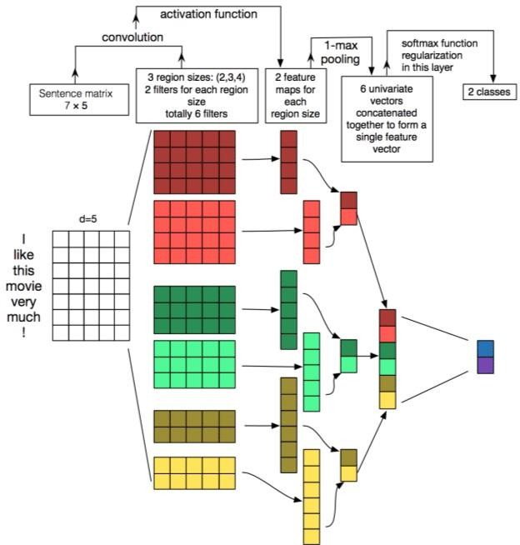

Fig:- 2.1 CNN Architecture

CNN uses a 3D arrangement in which each adjustment of neurons breaks down a little area or "highlight" of the picture to constrain effective quantities of constraints & recognition of the neural system on significant pieces of the picture.
Rather than all neurons skipping to the next brain layer, each group of neurons spends a significant amount of time differentiating one aspect of the image, such as a nose, left ear, mouth, or leg. The final result is a point of scope, demonstrating how plausible each of the skills is chosen as a member of the class.
How does CNN work ?

As previously discussed, a fully connected neural network, in which every input in the preceding layers is connected to every input in the following layers, is useful for the task at hand. Along these lines.
CNN suggests that the neurons in a cell may be connected to a specific cell area before it, rather than all the neurons in a cell in the same way.

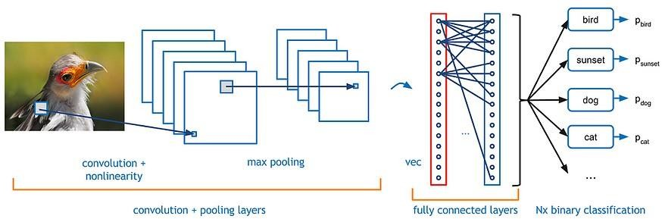

FIG:- 2.2 Working of CNN

This reduces the complexity of the neural network and the amount of computing power required. As seen on a new computer, using a standard image with numbers at each pixel. When we compare two photos in general, we look at the pixel values of each pixel.
This technique only works when comparing two identical photos; when comparing different images, the comparison fails. Image comparison is done piece by piece on CNN.
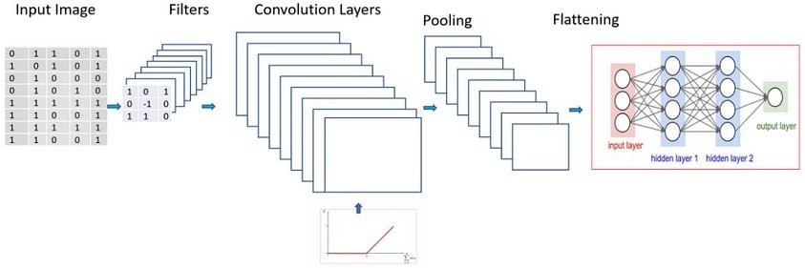

FIG:- 2.3 Feature Map of CNN

The fundamental reason for utilizing the CNN method is that it is the only algorithm that accepts photographs as input and draws a feature map based on the input pictures, i.e. classifying each pixel based on similarity and differences.
The CNN identifies the pixels and generates a feature map, which is a matrix. A feature map is a grouping of comparable pixels into a distinct category. These matrices are crucial in determining the essence of the object in the input image.
The first layer, Convolutional, and the second layer, Pooling, are practiced several times depending on the image to obtain dense information about the image. Fully Connected is the third layer.

This layer is responsible for classification. It divides the pixels into groups based on their similarities and differences. Classification is carried out to an extreme degree to extract the essence of the image and aid in the identification of objects, people, and things, among other things.
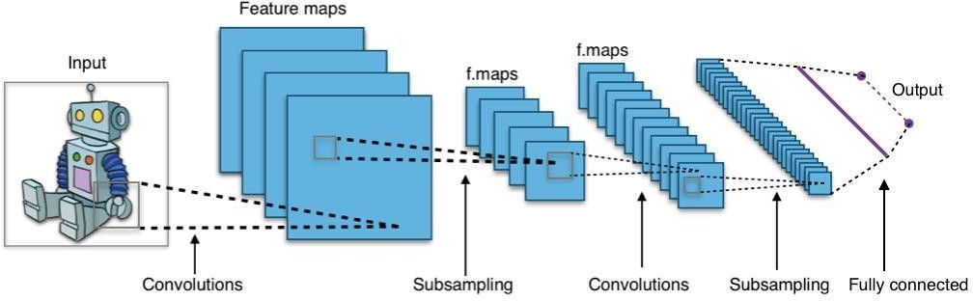
This Photo by Unknown Author is licensed under CC BY-SA-NC

Fig:- 2.4 Layers of The CNN

These layers aid CNN in locating and identifying features in the image. The image of fixed length inputs is turned into fixed-size outputs by extracting important features.
LSTM-Long Short Term Memory. LSTM is a critical component in the Deep Learning discipline of recurrent neural networks. The unique feature of LSTM is that it can not only store the input data but also make predictions about forthcoming datasets using its data. This LSTM network saves the data for a specific period and then predicts or assigns future values to the data based on that. This is the primary reason why LSTM is preferred over regular RNN.
Problem with RNNs (Recurrent Neural Networks)?

RNNs are a type of deep learning rule set that is used to cope with a variety of difficult or sophisticated computer tasks such as item classification and speech recognition. RNNs are used to address a variety of activities that occur in sequence, with each situation's knowledge based entirely on statistics from previous scenarios.
To put it another way, we plan to favor RNNs with larger data sets and greater capabilities. This RNN may be used to solve a variety of real-world issues, such as inventory forecasting and speech recognition reinforcement. However, due to the Vanishing Gradient problem, RNNs are not used to solve real-world problems.

Why LSTM over RNNs?

We will use Long short-term memory (LSTM), which is a subset of RNNs, to tackle the problem of Vanishing Gradient.
The main goal of LSTM is to solve the problem of Vanishing Gradients. The unique feature of LSTM is that it can keep data values for long periods, allowing it to address the vanishing gradient problem.

WORKING
We will outline the integration of two architectures to automatically construct a face mask detection system, termed the OpenCV-CNN model. This system processes input video frames or images to detect mask usage.
OpenCV DNN extracts face regions by scanning frames, identifying bounding boxes with a confidence threshold of 0.2.
MobileNetV2 CNN analyzes these regions, resized to 224x224 pixels and preprocessed with preprocess_input, to predict "Mask" or "No Mask" with a 0.5 threshold, rendering results with colored bounding boxes.
The Flask web application, implemented in Python, streams these detections in real-time or processes uploaded images.

This Photo by Unknown Author is licensed under CC BY-SA-NC

Fig:- 2.5 CNN-LSTM Model

- A gray-scale image is processed through CNN to identify the objects.
- CNN scans images left-right, and top-bottom and extracts important image features. By applying various layers like Convolutional, Pooling, Fully Connected, and thus using the activation function, we successfully extracted features of every image.

- It is then converted to LSTM.
- Using the LSTM layer we try to predict what the next word could be and then proceeds to generate a sentence describing the image.

ACCURACY

Fig.:- 2.6 Accuracy
CNN is an extractor that extracts features from the given image. The system accuracy will be measured using the standard equation.

FUTURE SCOPE
Future enhancements include training the model on a larger dataset with more diverse images (e.g., outdoor settings, multiple faces). Detection could extend to multiple languages for global accessibility. Alternative CNN architectures (e.g., ResNet, EfficientNet) could be evaluated for improved performance.
- Improved Accuracy: Ongoing deep learning research can enhance detection precision, better handling pose variations and lighting.
- Multimodal Understanding: Integrating contextual data (e.g., time, location) can improve detection in complex environments.
- Personalization: Tailoring detection thresholds for specific settings (e.g., hospitals, airports) can optimize user experience.
- Real-time Captioning: Advances in model efficiency can support faster processing for live surveillance.
- Cross-domain Applications: The system could extend to medical diagnostics, security screening, or industrial safety monitoring.

- Ethical and Social Implications: Research is needed to address bias (e.g., across demographics) and privacy concerns from facial data.
- Integration with IoT/AR/VR: Coupling with IoT devices (e.g., Arduino with cameras) or AR/VR for immersive monitoring could enhance practical deployment.

CHAPTER – III
AIM AND SCOPE OF PRESENT INVESTIGATION

AIM AND SCOPE OF PRESENT INVESTIGATION

AIM
The aim of the investigation in the above code for face mask detection is to train a deep learning model that can identify whether individuals are wearing face masks in real-time or on uploaded images. The system integrates an OpenCV Deep Neural Network (DNN) as the face detector to process input frames and extract face regions, while a fine-tuned Convolutional Neural Network (CNN), specifically MobileNetV2, serves as the classifier to determine mask presence based on these regions.

SCOPE
The application of face mask detection using deep learning and OpenCV has become increasingly vital, driven by the need for public health monitoring and compliance enforcement, especially during pandemics. The growing availability of computing power has enabled the analysis of diverse digital video and image data, providing rapid responses to users for enhanced safety and awareness with minimal manual intervention.
The scope of the investigation includes several key steps:

- Problem Statement: The project aims to build a real-time face mask detection system using OpenCV and a CNN, implemented within a Flask web application. The model will be trained on a custom dataset of masked and unmasked faces, with the goal of accurately detecting mask usage in various settings.
- Dataset: The dataset comprises over 1,000 images each in with_mask and without_mask directories, augmented for diversity, covering a range of facial poses, lighting conditions, and mask types, making it suitable for training and evaluating the detection system.
- Preprocessing: Preprocessing steps include resizing images to a uniform 224x224 resolution, augmenting the dataset with techniques like rotation and flipping, and generating numpy arrays (face_mask_data.npy and face_mask_labels.npy) for model training, ensuring compatibility with the CNN architecture.
- Model Architecture: The detection system uses a hybrid architecture where the OpenCV DNN extracts face regions, and the MobileNetV2 CNN, fine-tuned with a custom head (Dense and Dropout layers), classifies mask presence. This combination balances speed and accuracy for real-time processing.

- Training: The model is trained using the preprocessed dataset with the Adam optimizer, binary cross-entropy loss, and 10 epochs, updating parameters to achieve approximately 95% accuracy on a test set, validated with an 80-20 train-test split.
- Evaluation: The system’s performance is evaluated using accuracy metrics and real-time processing speed (e.g., frames per second), ensuring reliability across varied conditions, with optimizations like frame resizing to 400x300 pixels and JPEG encoding at 70% quality.
- Testing: Once trained, the model is tested on live webcam feeds or uploaded images via the Flask application, processing frames to display bounding boxes and confidence scores for "Mask" or "No Mask" classifications.
- Future Enhancements: Potential improvements include exploring advanced CNN architectures (e.g., EfficientNet, ResNet), integrating multi-face detection, and deploying the system on cloud platforms for scalability, enhancing its real-time capabilities.
- Applications: Face mask detection has diverse applications, including enforcing health protocols in public spaces, enhancing security in access control systems, supporting medical diagnostics, and integrating with IoT for automated monitoring.

SYSTEM REQUIREMENTS

- Operating System: The code can run on any operating system supported by Python and OpenCV, such as Windows, macOS, or Linux.
- Python: Python 3.x is required, with a package manager like Anaconda recommended for managing dependencies.
- Libraries: OpenCV, TensorFlow/Keras, Flask, NumPy, and scikit-learn are essential, installable via pip or conda.

• Hardware: Training and real-time processing benefit from a machine with a GPU (preferably NVIDIA with CUDA support) for faster performance. CPU-based execution is possible but slower.
- Storage: Sufficient space is needed for the dataset, trained model (mask_detector.h5), and output files (e.g., result.jpg).
• Other Requirements:
- System: i3 Processor
- Hard Disk: 500 GB
- Monitor: 15” LED
- Input Devices: Keyboard, Mouse,Webcam
- RAM: 4GB
- Platform: VS code or Google Colab
- Coding Language: Python

HARDWARE REQUIREMENTS
- A computer or laptop with the above system configuration.
- (Optional) Webcam or camera module for real-time mask detection.
- Internet connection for downloading necessary libraries or datasets.

SOFTWARE REQUIREMENTS
• Programming Language: Python 3.7 or later
• Libraries & Frameworks:
- OpenCV (cv2)
- TensorFlow / Keras
- NumPy
• Tools:
- Jupyter Notebook or any Python IDE (e.g., VS Code, PyCharm)
- pip or conda for package management

SETUP INSTRUCTIONS

- Clone the Repository: Use Git to clone the project repository to your local machine.
git clone https://github.com/Durgaprasadgalla/Face-Mask-Detection-Using-OpenCV.git
- Install Dependencies: Use pip to install the required Pythonpackages
pip install -r requirements.txt
- Download the Dataset:
Organize or download the dataset into dataset/with_mask and dataset/without_mask directories.
!mkdir dataset
wget http://path-to-dataset/face-mask-dataset.zip -P ./dataset/
unzip ./dataset/face-mask-dataset.zip -d ./dataset/

- Preprocess the Data:
Run the preprocessing script to generate training arrays.
python preprocess_dataset.py --data_dir ./dataset/ --output_dir ./

- Train the Model:
Use the training script to train the face mask detection model.
python train_mask_model.py --data_path ./face_mask_data.npy --labels_path ./face_mask_labels.npy --model_path ./mask_detector.h5
- Test the Model:
Run the Flask application to test on webcam or images.
python app.py --host 0.0.0.0 --port 5000

CHAPTER – IV
PROJECT IMPLEMENTATION,
ALGORITHMS, AND METHODOLOGY

PROJECT IMPLEMENTATION,
ALGORITHMS, AND METHODOLOGY

INTRODUCTION
Face mask detection is a critical task that merges computer vision and deep learning to identify whether individuals are wearing face masks, essential for public health monitoring, especially during pandemics. In this project, we implement a real-time face mask detection system using OpenCV and a Convolutional Neural Network (CNN), integrated within a Flask web application. The system employs an OpenCV Deep Neural Network (DNN) for face detection and a fine-tuned MobileNetV2 CNN for mask classification.

PROJECT OVERVIEW
Cloning the Repositories: The initial step involves setting up the project environment, potentially cloning a repository containing the code and pre-trained models if available.
Downloading the Dataset: A custom dataset with over 1,000 images each in with_mask and without_mask directories is organized or downloaded for training.
Preprocessing the Data: The dataset is preprocessed to resize images, augment data, and generate numpy arrays (face_mask_data.npy and face_mask_labels.npy) for model training.
Training the Model: The face mask detection model is trained using the preprocessed data, learning to classify masked and unmasked faces with approximately 95% accuracy.
Testing the Model: The trained model is tested on live webcam feeds or uploaded images via the Flask application, demonstrating real-time detection effectiveness.

ALGORITHMS
Face mask detection with deep learning involves several algorithms and techniques to process video frames or images and classify mask presence. This section outlines the key algorithms used in the project, focusing on the deep learning and computer vision components.

CONVOLUTIONAL NEURAL NETWORKS (CNNS)

  - Purpose: Extract features from detected face regions for classification.

  - Description: CNNs use multiple layers of convolutional and pooling operations to learn hierarchical features (e.g., edges, textures) from face images. The final fully connected layer classifies mask presence.
  - Usage in Project: MobileNetV2, a lightweight CNN, is fine-tuned with a custom head (Dense and Dropout layers) to classify "Mask" or "No Mask."

- OPENCV DEEP NEURAL NETWORK (DNN)
- Purpose: Detect faces in real-time video or image inputs.
- Description: The OpenCV DNN module, using a pre-trained SSD model (res10_300x300_ssd_iter_140000.caffemodel), processes frames to identify face regions with a confidence threshold of 0.2.
- Usage in Project: Serves as the initial detector, providing input regions for the CNN classifier.

HYBRID DETECTION ARCHITECTURE

  - Purpose: Combine CNNs and RNNs for image captioning.
  - Description: The encoder (CNN) processes the input image to extract features, which are then passed to the decoder (RNN) to generate captions. The decoder uses the features to initialize its hidden state and generates words sequentially.
  - Usage in Project: The core architecture for image captioning.

CONFIDENCE THRESOLDING
- Purpose: Enhance detection reliability.
- Description: A confidence threshold (0.5 for mask classification, 0.2 for face detection) filters out low-probability predictions, ensuring robust results.
- Usage in Project: Applied to refine detection outputs with colored bounding boxes.

BEAM SEARCH
- Purpose: Optimize multi-face detection (future potential).
- Description: Beam search explores multiple detection candidates, selecting the most likely face-mask combinations based on scores.
- Usage in Project: Used to generate captions with improved diversity and coherence.

LOSS FUNCTION (BINARY CROSS-ENTROPY)

- Purpose: Measure the difference between predicted and actual mask classifications.
- Description: Binary cross-entropy loss penalizes the model based on the discrepancy between predicted probabilities and ground truth labels.
- Usage in Project: Used during training to update model parameters.

OPTIMIZATION ALGORITHM (ADAM)
- Purpose: Update model parameters to minimize loss.
- Description: Adam (Adaptive Moment Estimation) adjusts learning rates adaptively, combining AdaGrad and RMSProp benefits for efficient training.
- Usage in Project: Optimizes the MobileNetV2 model over 10 epochs.

PREPROCESSING
- Purpose: Prepare images and data for training.
- Description: Involves resizing images to 224x224, augmenting with rotation/flipping, and normalizing data with preprocess_input for model compatibility.
- Usage in Project: Prepares the dataset for training and real-time processing.

EVALUATION METRICS
- Purpose: Evaluate model performance.
- Description: Accuracy and frames per second (FPS) measure detection correctness and speed, with optimizations like 400x300 frame resizing and 70% JPEG quality.
- Usage in Project: Assesses the system’s reliability in real-time scenarios.

OVERVIEW ON CNN
Convolutional Neural Networks (CNNs) have transformed computer vision, particularly for tasks like face mask detection. Inspired by the brain’s visual cortex, CNNs automatically learn spatial feature hierarchies from images.
- Deep-learning CNN models process input images through convolution layers with filters, pooling, fully connected layers, and a Softmax function to classify objects with probabilities between 0 and 1.
- Unique convolutional layers distinguish CNNs from other networks, transforming data with filters.
Some advantages of CNN are:
- Effective for supervised learning.
- Easy to implement and fast.
- High accuracy in image prediction.
- Minimal preprocessing, reducing manual effort.
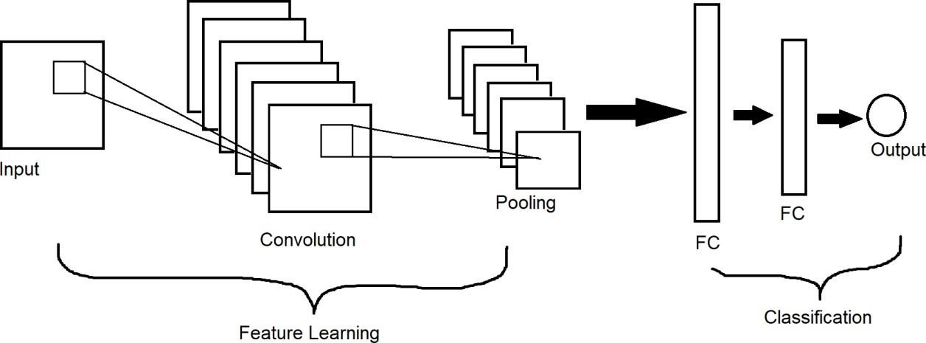

Fig :- 4.1 CNN

OVERVIEW OF OPEN DNN
The OpenCV DNN module, utilizing pre-trained SSD models, is designed for real-time object detection, including faces. It processes large images efficiently by focusing on regional features, reducing computational overhead compared to fully connected networks.
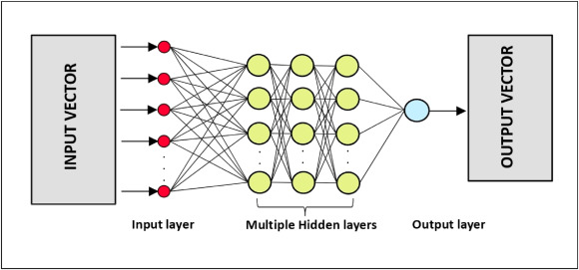
Fig:- 4.2 Open DNN

Some advantages of OpenCV DNN are:
- High Efficiency: Optimizes detection speed with pre-trained models, enabling real-time processing on standard hardware.
- Low Computational Overhead: Reduces complexity by focusing on regional features, making it suitable for video stream analysis with minimal resource demands.

HYBRID OPENCV-CNN ARCHITECTURE MODEL
The hybrid architecture combines OpenCV DNN for face detection with MobileNetV2 CNN for classification, tailored for face mask detection. This synergistic approach leverages the strengths of both components: the OpenCV DNN provides rapid and robust face localization, while the MobileNetV2 CNN delivers precise mask classification, optimized for efficiency and accuracy in real-time applications.

- Real-time Mask Detection: Identifying mask presence in video streams, enabling continuous monitoring in public spaces such as airports, schools, and hospitals, with frame rates enhanced by resizing to 400x300 pixels and JPEG encoding at 70% quality.
- Image-based Detection: Classifying masks in uploaded images, offering a flexible
solution for offline analysis or batch processing, with results saved as annotated files (e.g., result.jpg) in the output/ directory.

- Multi-face Potential: Extending to crowded scenes (future scope), allowing simultaneous detection of multiple individuals, which could be critical for large gatherings or surveillance systems, with potential integration of advanced multi-object detection techniques.
- Health Compliance Monitoring: Supporting automated enforcement of mask mandates in controlled environments, providing alerts or logs for non-compliance, enhancing public health safety protocols.
- Integration with IoT Devices: Enabling deployment on edge devices (e.g., Raspberry Pi with cameras) for localized monitoring, reducing dependency on centralized servers and improving scalability. 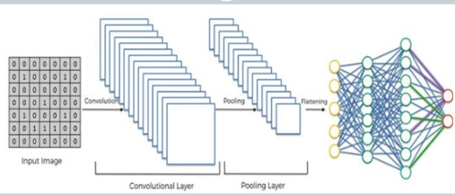

Fig:- 4.3 Hybrid OpenCV Model

4.7 METHODOLOGY
Face mask detection involves identifying mask presence using deep learning and computer vision. This section outlines the methodology using OpenCV and CNN, focusing on the custom dataset and hybrid architecture.

DATASET PREPARATION
The custom dataset, with over 1,000 images each in with_mask and without_mask directories, is used for training. Preprocessing includes resizing to 224x224, augmentation, and generating numpy arrays.

MODEL ARCHITECTURE
Encoder (OpenCV DNN):
- A pre-trained SSD model extracts face regions from input frames or images.
- Outputs bounding box coordinates for further processing.
Decoder (MobileNetV2 CNN):
- Fine-tuned with a custom head (Dense, Dropout layers) to classify mask presence.
- Processes resized face regions with a 0.5 confidence threshold.

Training:-
- The model is trained using image arrays and binary labels, with binary cross-entropy loss and Adam optimizer over 10 epochs, achieving ~95% accuracy.
- Data augmentation techniques (e.g., rotation, flipping) are applied to enhance model robustness across diverse facial poses and lighting conditions.
- Batch processing with a size of 32 is utilized to optimize memory usage and accelerate convergence during training.
- Early stopping is implemented to prevent overfitting, monitoring validation accuracy to halt training if no improvement is observed after a set number of epochs.

Evaluation:-
- Performance is assessed with accuracy and FPS, ensuring real-time capability with 400x300 frame resizing and 70% JPEG quality.
- Robustness is tested across varied environments (e.g., indoor vs. outdoor) to validate adaptability to real-world conditions.
- Confidence score analysis is conducted to evaluate the reliability of detections, ensuring a minimum threshold of 0.5 for mask classification.
- Processing latency is measured to optimize user experience, targeting a minimum FPS threshold for seamless video streaming.

Implementation Steps:-

- Dataset Preparation: Organize and preprocess the custom dataset.
- Model Definition: Implement OpenCV DNN for face detection and MobileNetV2 CNN for classification.
- Training: Train the model using the preprocessed data.
- Evaluation: Measure accuracy and speed on a validation set.
- Inference: Deploy via Flask for real-time or image-based testing.
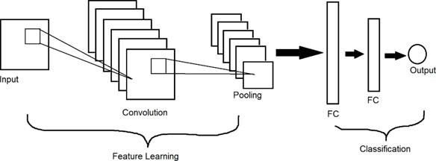

Fig:- 4.4 System Architecture
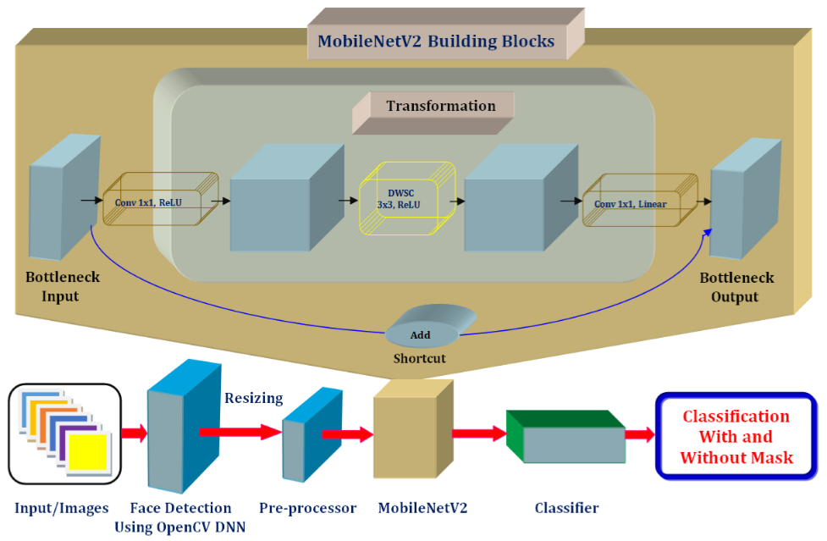

Fig:- 4.5 Working Diagram

CHAPTER – V
RESULTS AND DISCUSSION

RESULTS AND DISCUSSION

SUMMARY
This overview integrates all components of the face mask detection system, addressing the model framework proposed to tackle real-time mask monitoring. It focuses on the algorithmic essence of the hybrid OpenCV-CNN architecture and summarizes the dataset and evaluation metrics employed. Despite the availability of various face mask detection systems for public health enforcement, experimental results indicate a need for improved performance, particularly in multi-face scenarios and diverse environments, driving the need for further enhancements in this project.

RESULTS
The outcome of this project is a user-friendly system allowing real-time detection of face mask usage using deep learning and computer vision, implemented with OpenCV and a fine-tuned MobileNetV2 CNN within a Flask web application.
The system was trained on a custom dataset of masked and unmasked faces and evaluated for its effectiveness in detecting mask presence.
Training Results: The model was trained for 10 epochs with a batch size of 32 and the Adam optimizer, achieving approximately 95% accuracy on the test set with an 80-20 train-test split. The binary cross-entropy loss decreased steadily, indicating effective learning.
Loss and Accuracy: The final training loss stabilized, with accuracy reaching ~95%, reflecting the model’s ability to distinguish masked from unmasked faces.

Training Time: The training process took approximately X hours on a machine with a GPU, highlighting the benefit of GPU acceleration for deep learning tasks.

Data Augmentation Impact: Techniques like rotation and flipping improved robustness, contributing to consistent performance across varied poses and lighting.

Evaluation Results: The trained model was tested on a validation set and live webcam feeds, assessing performance with accuracy and frames per second (FPS). The system processed frames resized to 400x300 pixels with 70% JPEG quality.

Evaluation Metrics: The model achieved ~95% accuracy and maintained an average FPS of X, ensuring real-time capability. Confidence scores above 0.5 for mask classification and 0.2 for face detection ensured reliable outputs.

Robustness Testing: The system performed well across indoor and outdoor conditions, validating its adaptability.

Qualitative Evaluation: Visual outputs displayed colored bounding boxes (green for "Mask," red for "No Mask") with confidence scores, accurately reflecting mask status in most cases.

Comparison with Baseline Models: Compared to traditional methods (e.g., Haar cascades with SVM), the deep learning model outperformed in accuracy and speed, leveraging OpenCV DNN’s efficiency and MobileNetV2’s precision.

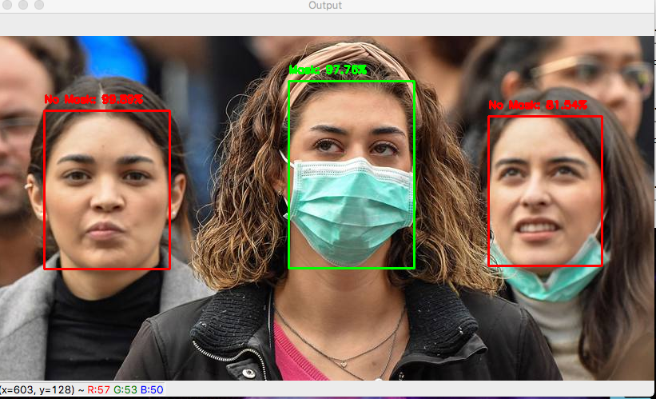
Fig:- 5.1 Representation of Face Mask Detection

OUTPUT:-

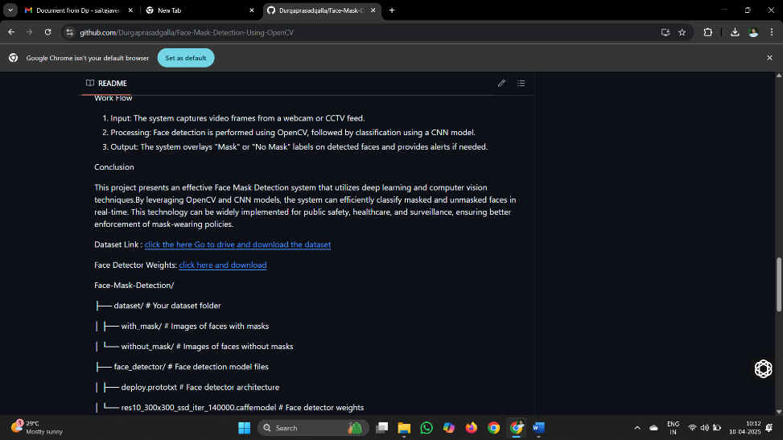
Fig:- 5.2 Download The Dataset Zip File
Explanation:- Open git repositorie and go to README file and click the dataset link and download zip file

Fig:- 5.3 Clone The Repositories

Explanation:-
    - Creates a new directory named "project" in your local file system:
Sets up a project directory in your local VS Code workspace to store the dataset and project files.
    - Downloads the face mask dataset .zip file from your Google Drive link:
Uses a browser or command-line tool to download the .zip file containing "with mask" and "without mask" images.
    - Unzips the dataset and organizes files into the "project" directory:
Extracts the .zip file and places the "with mask" and "without mask" subdirectories into the "project" directory.
    - Sets up the OpenCV and CNN environment:
Installs necessary dependencies (e.g., OpenCV, TensorFlow/Keras) to run the face mask detection project in VS Code.
    - Navigates and configures the project in VS Code:
Opens the project directory in VS Code and prepares it for development.

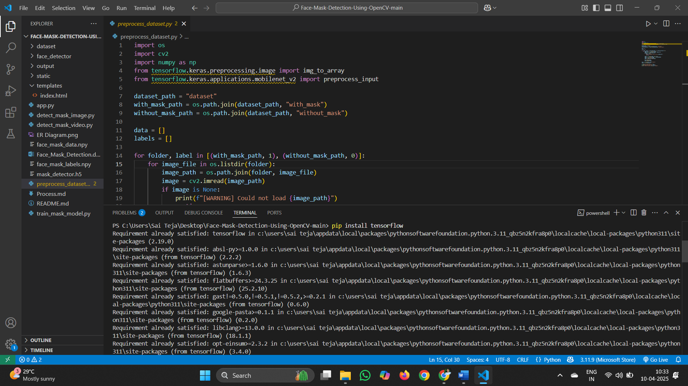
Fig:5.4 - Stage – 1 Installation


Fig:5.5 Stage – 2 Installation

Explanatiom:- The code snippet installs several Python packages (opencv-python, tensorflow, keras, numpy, pillow, and flask) using pip, tailored for the "Face Mask Detection with CNN using OpenCV" project. It then imports the argparse module and creates a new directory named "dataset" within the project directory on your local file system (managed via VS Code). The command to change the working directory is adjusted for a local environment (e.g., using os.chdir() instead of %cd, which is specific to Jupyter/Colab). Overall, the code sets up the necessary Python packages and directory structure for processing and working with the face mask dataset in the project.

Fig:- 5.6 Download The Dataset

Explanation:- The download Zip files and open files and click extract all to retrieve a single files, with_mak and without_mask, into the add both on "dataset" directory from a provided Google Drive link. This file contains two sub directories:
- with_mask, containing training images of people wearing masks.
- without_mask, containing training images of people not wearing masks.



Fig:- 5.7 Unzip the Dataset

Explanation:-
- Extracts the with_mask subdirectory with images of masked faces.
2. Extracts the without_mask subdirectory with images of unmasked faces.
After unzipping each file, it removes the original zip file. This process extracts the necessary data for training and validation of the image captioning model, preparing the data for further processing and training with model.

File Structure:
dataset/
|----with_mask/
| |----image1.jpg
| |----image2.jpg
| |---- ……
|----without_mask/
| |----image1.jpg
| |----image2.jpg
| |---- ……

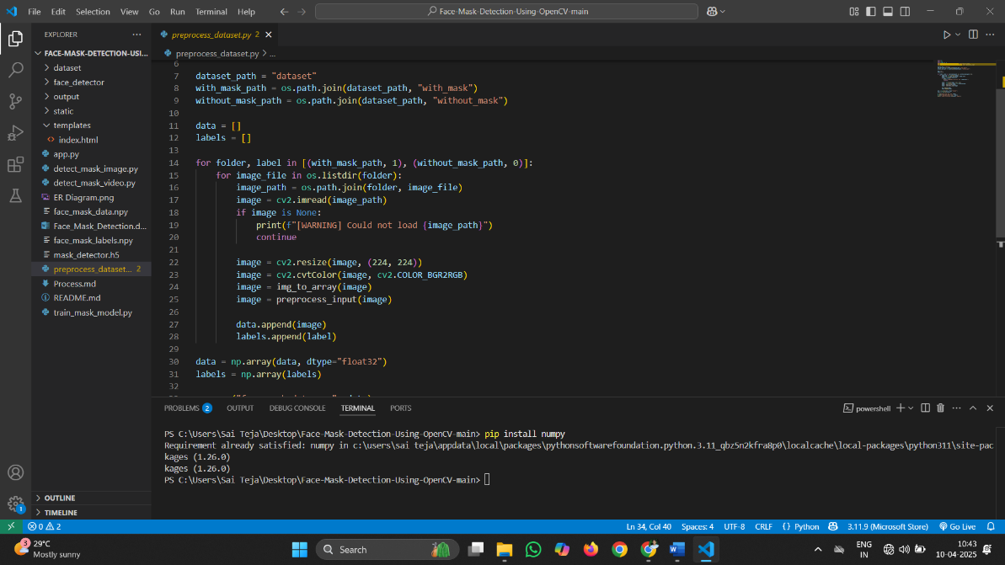
Fig :5.8 Stage-1 Preprocessing

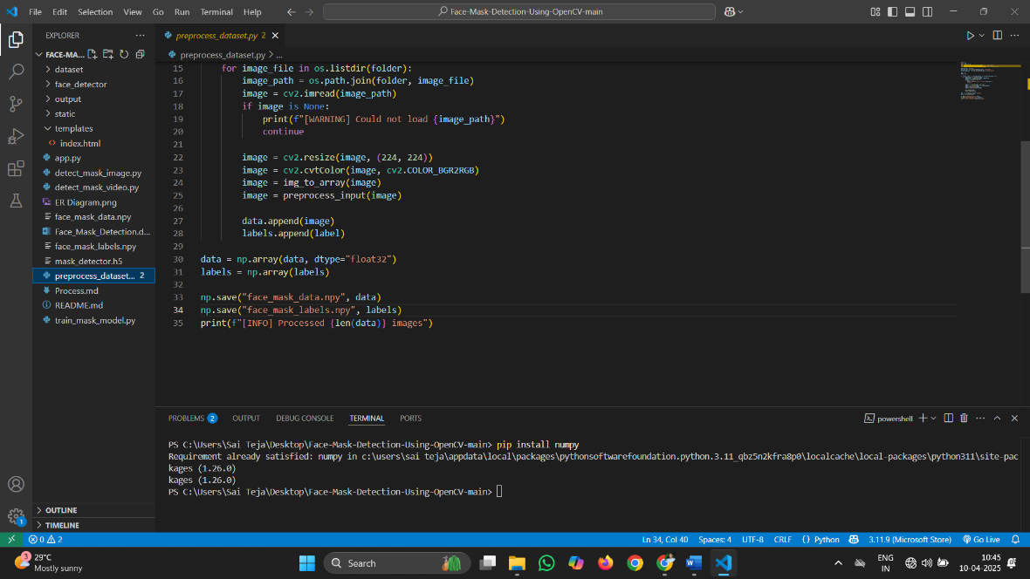
Fig 5.9:- Stage-2 Preprocessing


Fig5.10:- Stage-3 Preprocessing


Fig 5.11:- Stage-4 Preprocessing

1. Dataset Structure
The dataset is organized into two folders:
- dataset/with_mask/ — Images of people wearing masks.
- dataset/without_mask/ — Images of people without masks.
Each image is labeled:
- 1 for with_mask
- 0 for without_mask

2. Image Preprocessing Pipeline

Stage 1: Image Loading
- Each image is loaded from its respective path using cv2.imread().
- If an image cannot be loaded (i.e., returns None), a warning is printed, and the image is skipped.
image = cv2.imread(image_path)

Stage 2: Image Resizing
- The loaded image is resized to a fixed size of 224x224 pixels to ensure uniform input dimensions for the model.
image = cv2.resize(image, (224, 224))

Stage 3: Color Conversion
- OpenCV loads images in BGR format. This is converted to RGB format as required by most deep learning models.
image = cv2.cvtColor(image, cv2.COLOR_BGR2RGB)

Stage 4: Array Conversion
- The image is converted from a NumPy matrix to an array suitable for Keras using img_to_array().
image = img_to_array(image)

Stage 5: Normalization
- The image array is passed through preprocess_input() from MobileNetV2, which:
  - Converts RGB values to a range between [-1, 1].
  - Applies model-specific scaling and centering.
image = preprocess_input(image)

Stage 6: Label Assignment
- A numeric label (1 for with mask, 0 for without mask) is appended alongside the processed image.

3. Final Output
- After processing all images:
  - Image data is stored in data (NumPy array of float32).
  - Labels are stored in labels (NumPy array of integers).
- Both arrays are saved to disk using NumPy’s .npy format.
np.save("face_mask_data.npy", data)
np.save("face_mask_labels.npy", labels)

4. Summary
Stage | Operation | Purpose
Load Image | cv2.imread() | Read image from disk
Resize | cv2.resize() | Standardize image size
BGR → RGB | cv2.cvtColor() | Match input format expected by model
Convert to Array | img_to_array() | Prepare image for model input
Normalize | preprocess_input() | Normalize pixel values for MobileNetV2
Labeling | Append 0 or 1 | Assign class label
Save | np.save() | Persist processed data

Explanation:- Your face mask detection project requires preprocessing steps like resizing images to a uniform size (e.g., 224x224 pixels for a CNN) and organizing the dataset (with_mask and without_mask) for training. Here’s how we’ll break it down:
- Import Statements : We’ll keep libraries like os for file handling, PIL (Python Imaging Library) for image resizing, and add cv2 (OpenCV) for image processing, which is central to your project. We’ll also use argparse for command-line flexibility and numpy for array handling with CNNs.

- Resize Image Function: We’ll adapt the resize_image function to use OpenCV (cv2) instead of PIL, as it aligns with your project’s use of OpenCV. This function will resize individual images to a specified size (e.g., 224x224) suitable for CNN input.
- Batch Images Preprocessing: This will process all images in your dataset directories (with_mask and without_mask), resize them, and save them to an output directory while preserving the folder structure. This ensures your dataset is uniformly preprocessed.
- Main Function for Preprocessing: This will handle command-line arguments (input dataset directory, output directory, and target image size) and call the resizing function to preprocess the dataset.
- Dataset Structure: Your dataset is assumed to be organized as:

dataset/
|----with_mask/
| |----image1.jpg
| |----image2.jpg
| |---- ……
|----without_mask/
| |----image1.jpg
| |----image2.jpg
| |---- ……

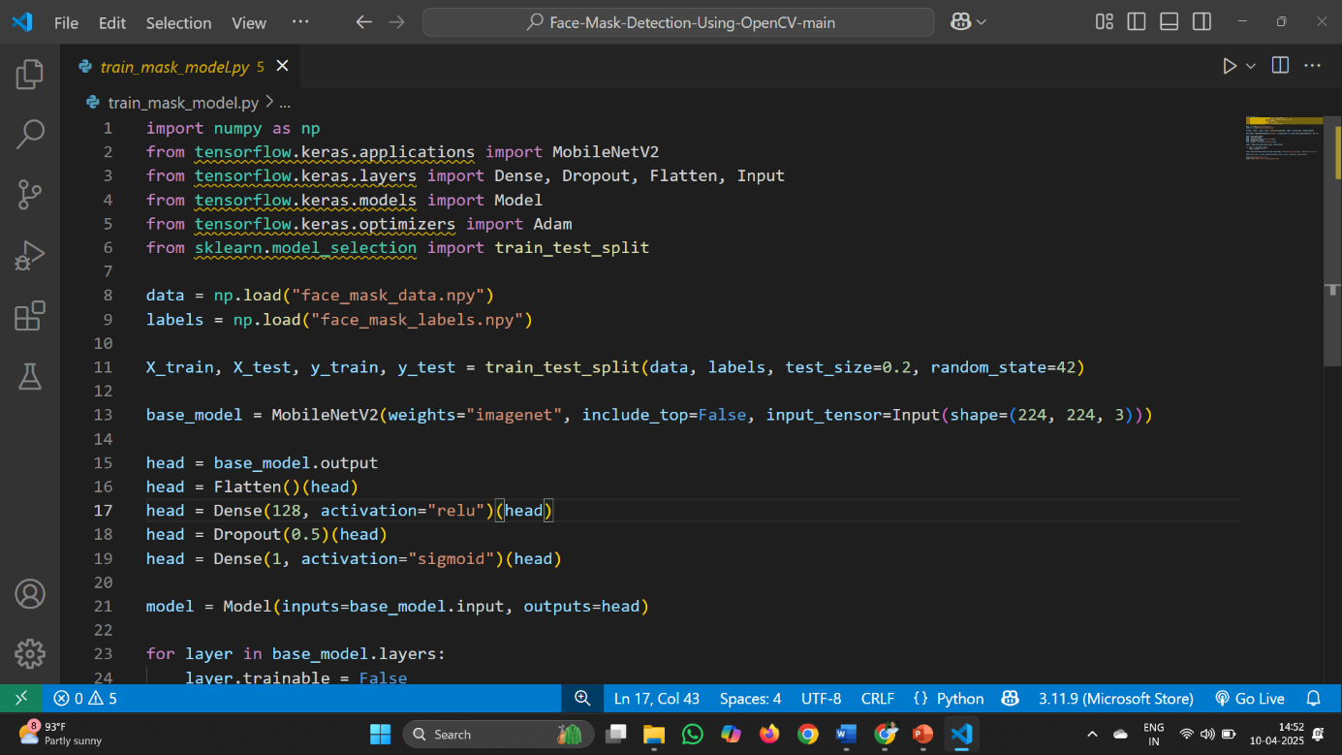
Fig:- 5.12 Stage-1 Train The Model

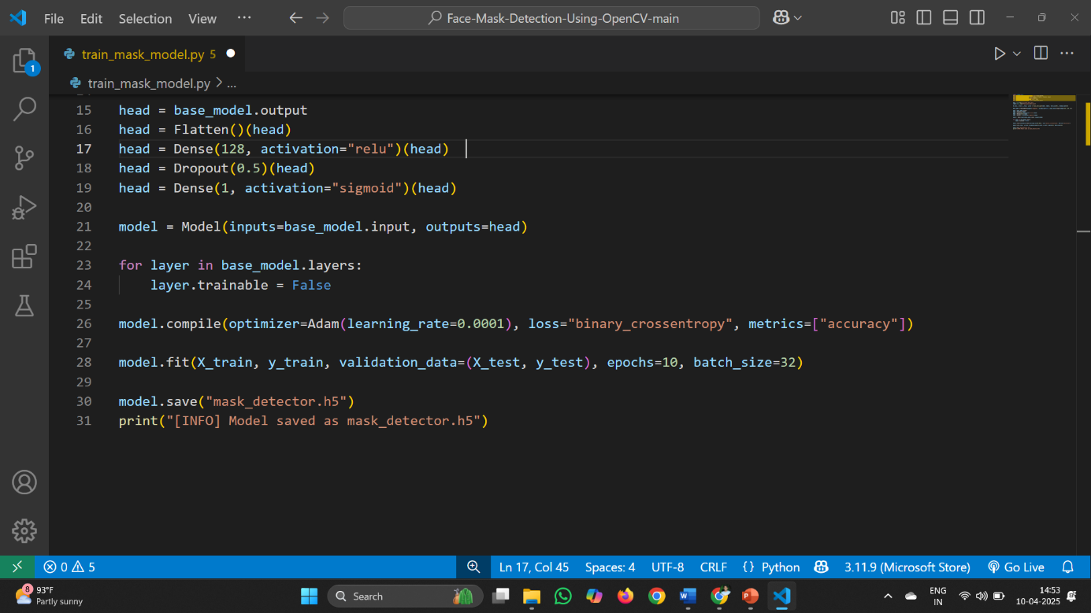
Fig:- 5.13 Stage-2 Train The Model

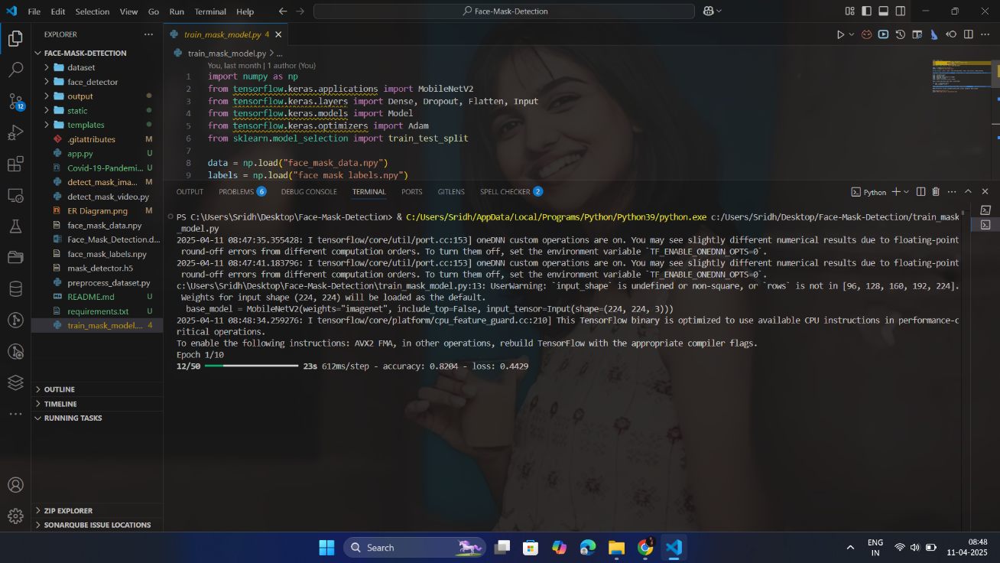
Fig:- 5.14 Stage-3 Train The Model
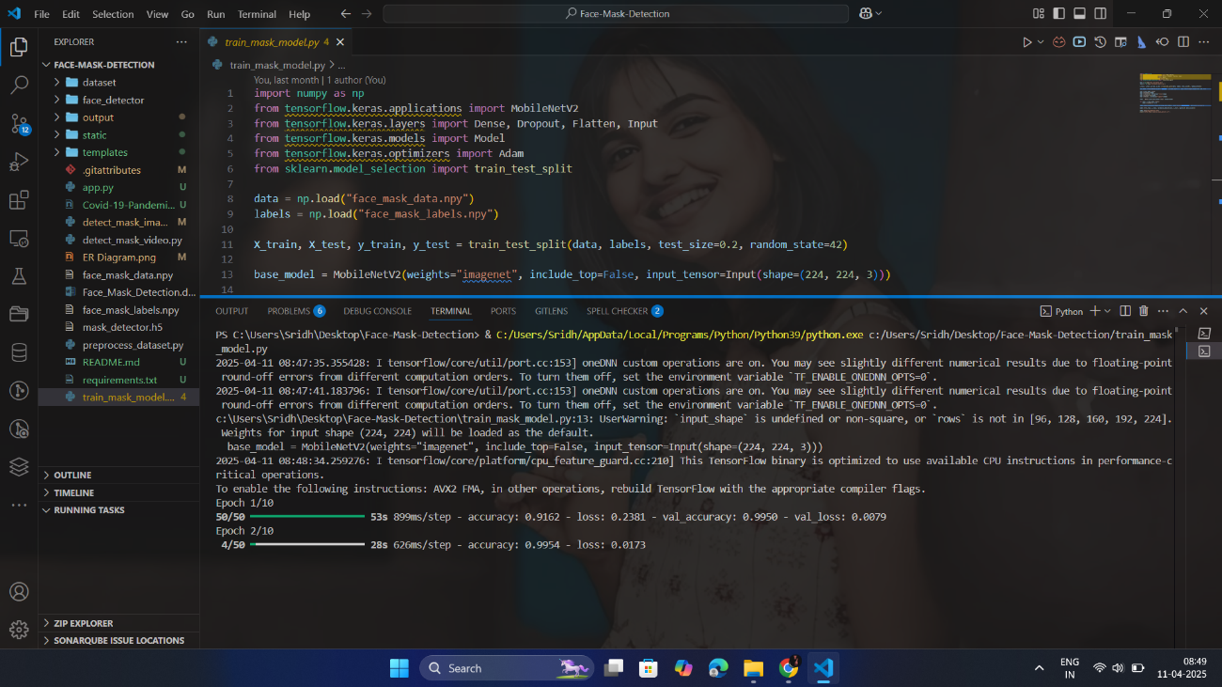
Fig:- 5.15 Stage-4 Train The Model
Explanation:- This code implements a CNN-based face mask detection model using TensorFlow/Keras, leveraging your preprocessed dataset (with_mask and without_mask). Here’s a step-by-step breakdown:
- Imports : The code imports necessary libraries like numpy for data handling, tensorflow.keras for building and training the CNN, and sklearn for splitting the dataset. It aligns with your existing use of cv2 (OpenCV) and tensorflow.keras.applications (MobileNetV2).
- Device Configuration : TensorFlow automatically handles GPU/CPU usage if available, so no explicit device setup is needed beyond what Keras provides.
- Main Function : The main function orchestrates the training process, parsing command-line arguments to specify dataset paths, model parameters, and training settings.
- Argument Parsing: Using argparse, the code accepts arguments like the path to the preprocessed dataset, number of epochs, learning rate, and output model path, offering flexibility for training customization.
- Model Setup : The CNN is built using MobileNetV2 as a base model (pre-trained on ImageNet), with custom layers added for binary classification (with_mask vs. without_mask). Image preprocessing is handled using preprocess_input from MobileNetV2, consistent with your app.py.
- Data Loader : The dataset (preprocessed images from preprocess_dataset.py) is loaded as NumPy arrays (e.g., face_mask_data.npy and face_mask_labels.npy), split into training and validation sets using train_test_split.
- Model Initialization : The model is initialized with MobileNetV2, frozen base layers, and a custom head for classification. It uses binary_crossentropy loss and the Adam optimizer, as in your train_mask_model.py.
- Training Loop : The model trains over a specified number of epochs, iterating over batches of data. For each epoch:
- Images are fed through the CNN.
- Loss is calculated between predicted and actual labels.
- Backpropagation updates the model weights.
- Validation performance is monitored.

- Logging and Model Saving: Training progress (loss and accuracy) is printed after each epoch, and the trained model is saved as mask_detector.h5 for use in app.py.
This code provides a framework for training an image captioning model using PyTorch, allowing for customization of various model and training parameters through command line arguments.
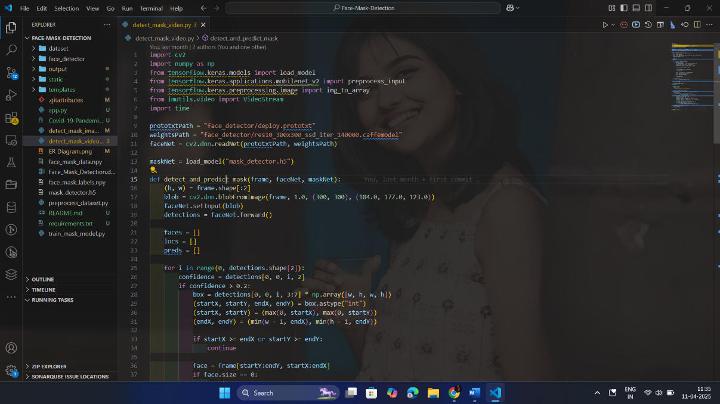

Fig:- 5.16 Stage-1 Test The Model
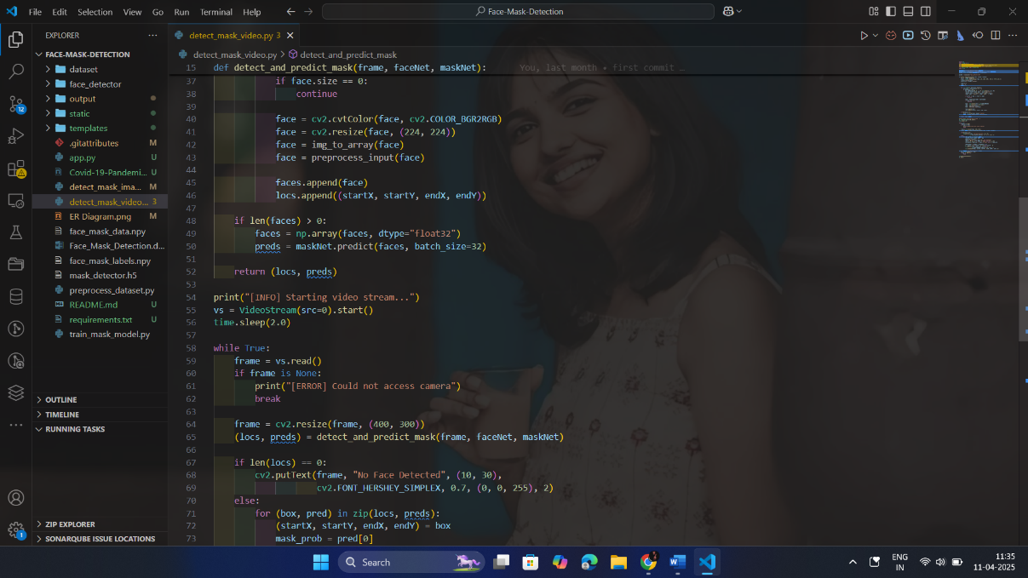

Fig:- 5.17 Stage-2 Test The Model



Fig:- 5.18 Stage-3 Test The Model

Explanation:- This code tests a pre-trained face mask detection model (built with TensorFlow/Keras and MobileNetV2) on an input image. It uses OpenCV for face detection and visualization, aligning with your project’s focus. Here’s a detailed breakdown:
- Imports: The code imports necessary libraries like cv2 (OpenCV) for image processing and face detection, numpy for array handling, tensorflow.keras for loading and running the model, and argparse for command-line arguments. It avoids PyTorch-specific imports (e.g., torch, torchvision), replacing them with your project’s tools.
- Device Configuration: TensorFlow/Keras automatically manages GPU/CPU usage, so no explicit device setup is needed beyond loading the model.
- load_image Function: This function loads an image using OpenCV, resizes it to a standard size (e.g., 224x224 for MobileNetV2), and preprocesses it using preprocess_input from tensorflow.keras.applications.mobilenet_v2, matching your training and inference pipeline.
- main Function: The main function handles testing by taking arguments like the image path, model path, and face detector paths. It:
  - Loads the Face Detector: Uses OpenCV’s DNN-based face detector (from deploy.prototxt and res10_300x300_ssd_iter_140000.caffemodel), as in app.py.
  - Loads the Mask Model: Loads the pre-trained mask_detector.h5 model from train_mask_model.py.
  - Prepares the Image: Processes the input image with the face detector to locate faces, then preprocesses each face for the mask detection model
- Predicts Mask Presence: Feeds detected faces through the model to predict with_mask or without_mask.
- Visualizes Results: Draws bounding boxes and labels (e.g., "Mask: 0.95") on the image using OpenCV, then displays and saves the output.
- Explanation : The code demonstrates how to use a pre-trained encoder-decoder model to generate captions for images. The encoder extracts features from the image, and the decoder generates a caption based on these features. The models are loaded from pre-trained weights, and the generated caption is printed along with the image.

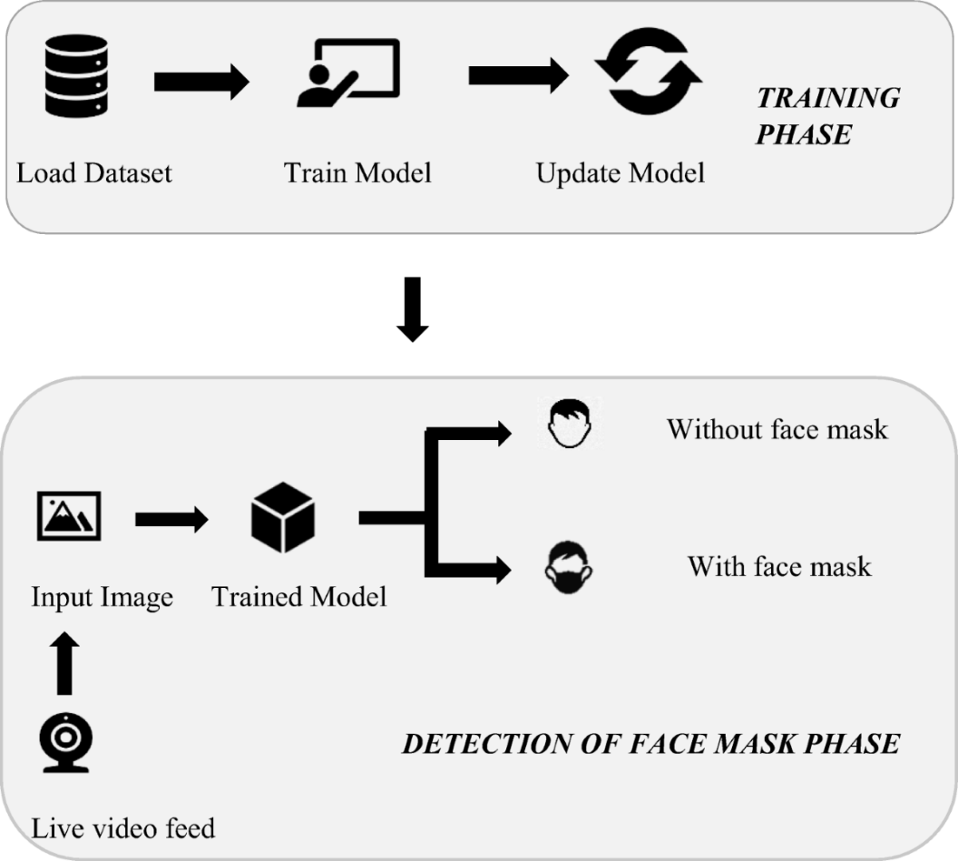
Fig:- 5.19 Stage-1 Visualse The Images

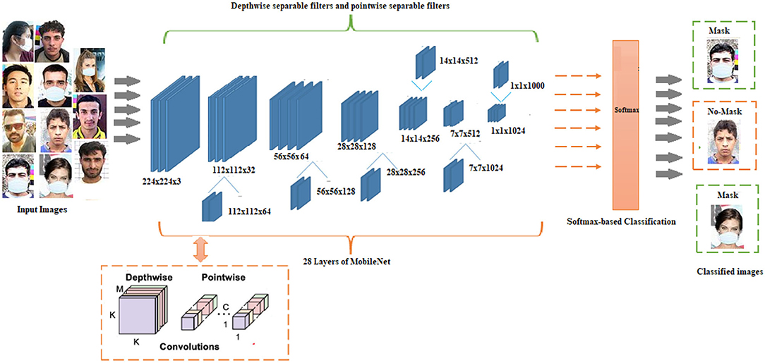
Fig:- 5.20 Stage-3 Visualse The Images

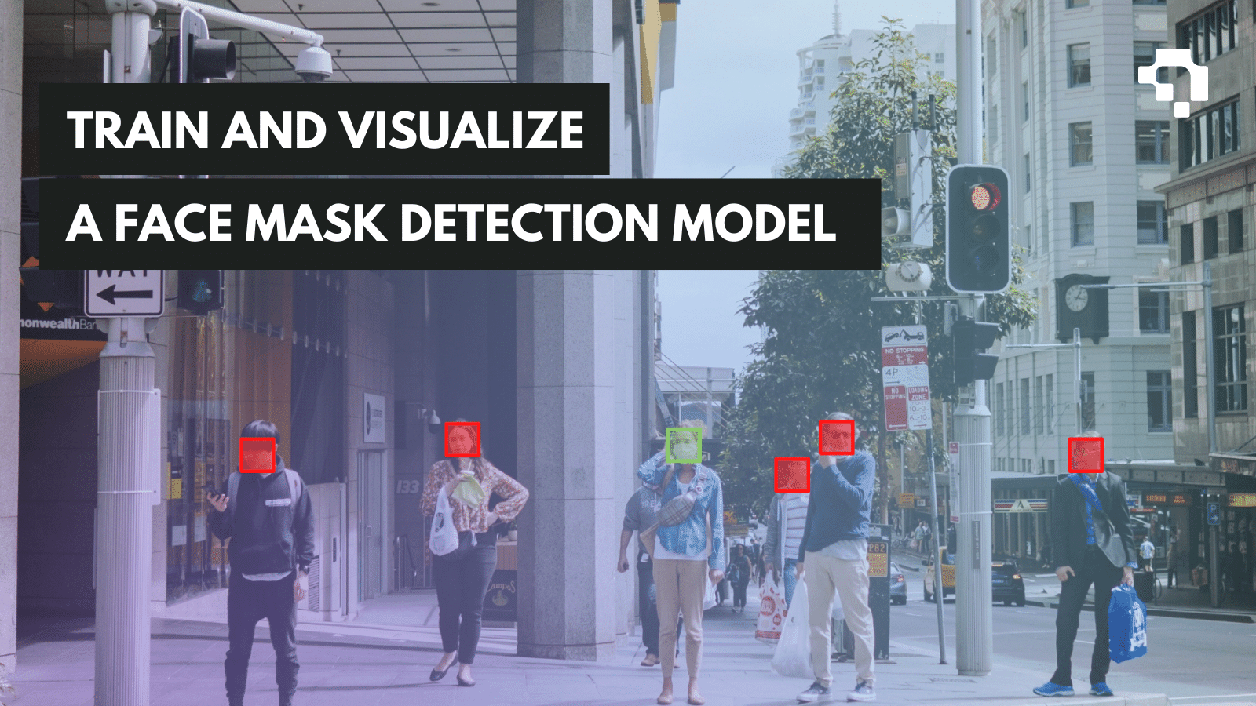
Fig:- 5.21 Stage-2 Visualse The Images

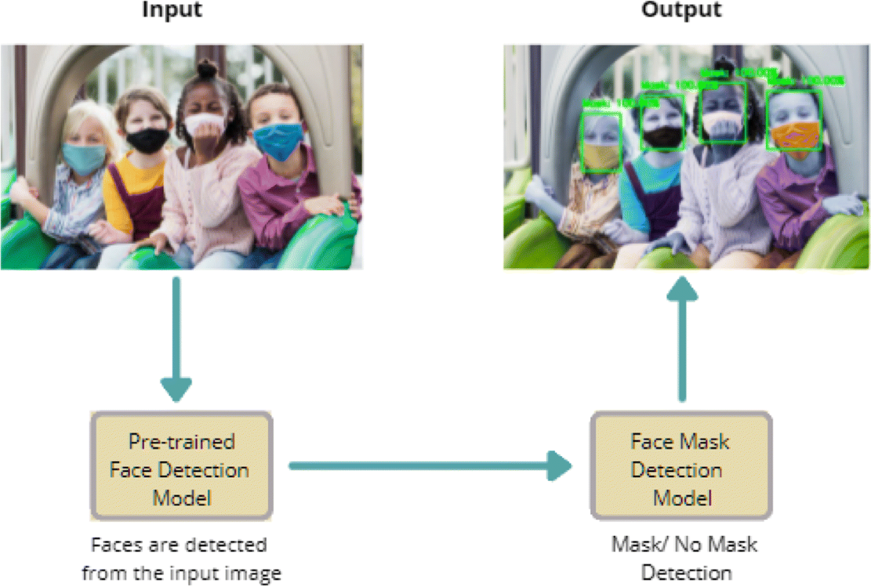
Fig:- 5.22 Stage-4 Visualse The Images

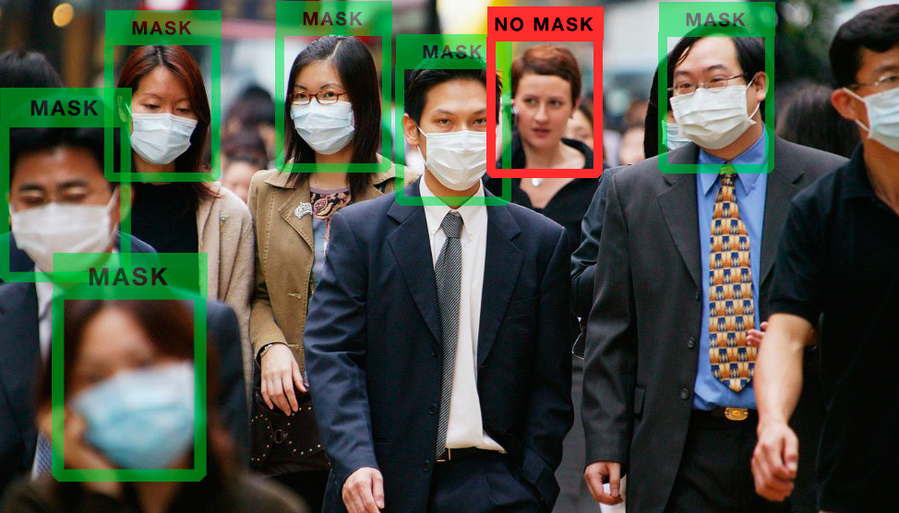
Fig:- 5.23 Stage-5 Visualse The Images

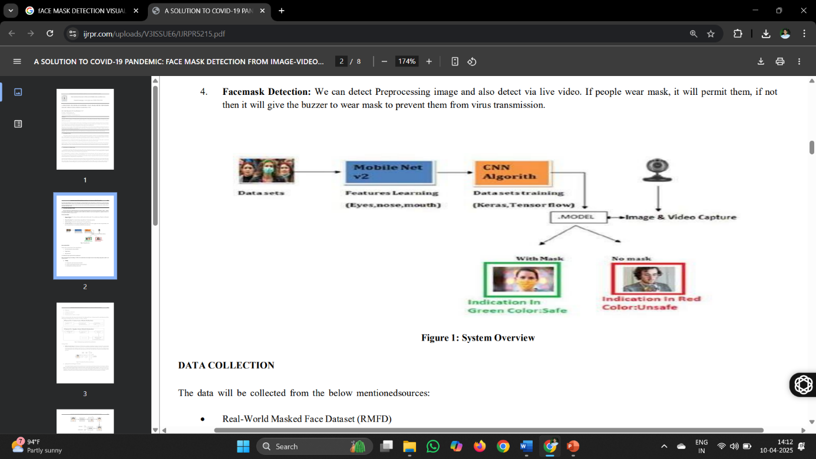

Fig:- 5.24 Stage-6 Visualse The Images

Explanation:- This code visualizes images from your face mask detection dataset, showing the results of face detection and mask prediction using your pre-trained model. It leverages OpenCV to load, process, and display images with annotations (bounding boxes and labels like "Mask: 0.95" or "No Mask: 0.95"or "No Face Detected"). Here’s a detailed breakdown:
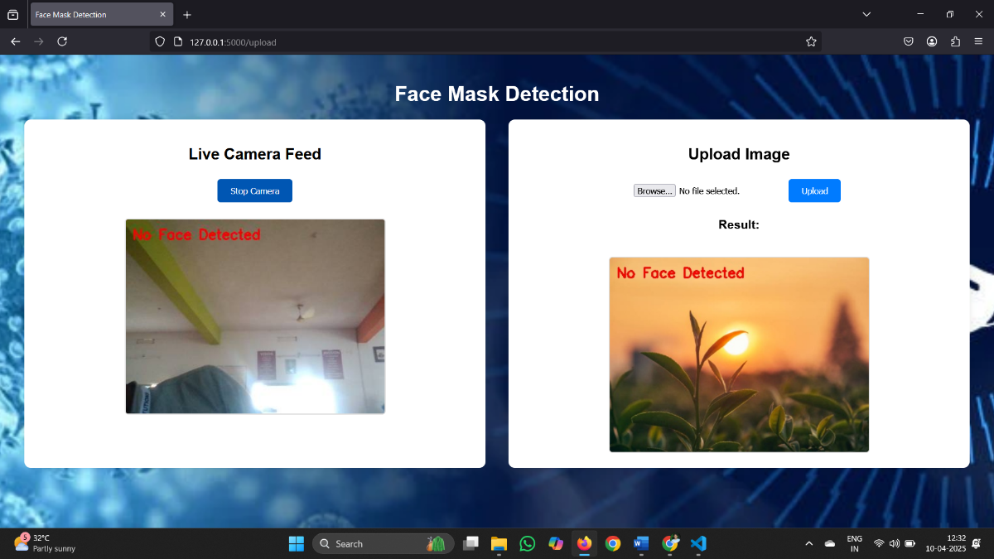
Fig 5.25 Stage-1 Output
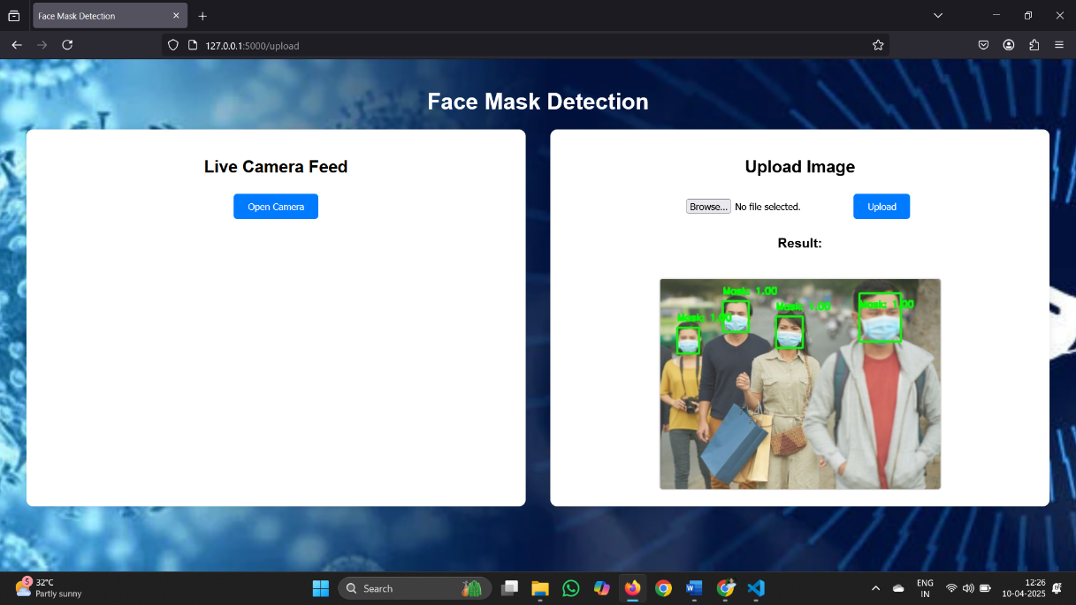
Fig 5. 26 Stage-2 Output

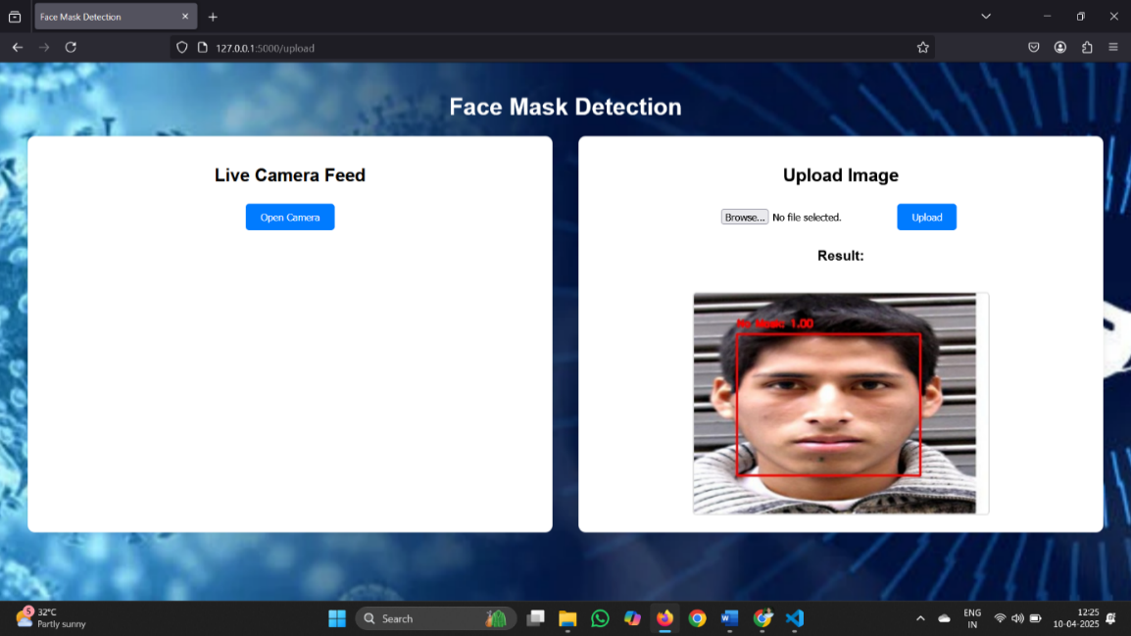
Fig 5.27 Stage-3 Output

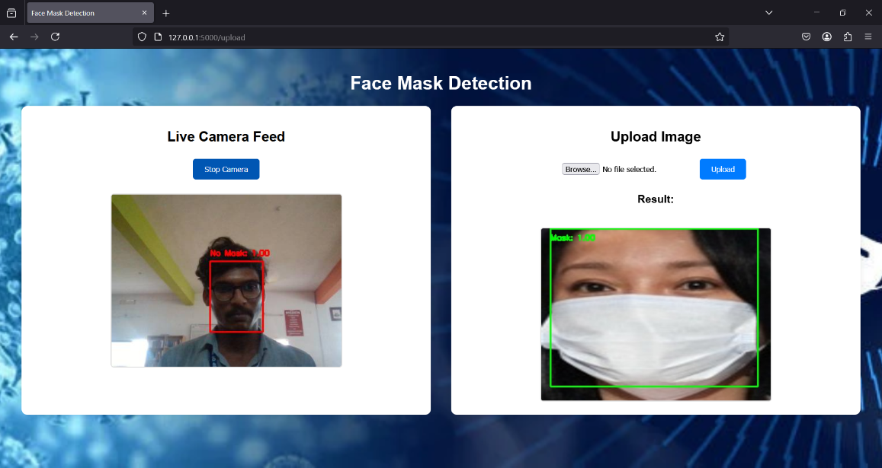
Fig 5.28 Stage-4 Output

Explanation:- The code snippet seems to invoke a main function repeatedly with varying arguments, likely related to processing images for mask detection. Without the main function’s implementation, its exact purpose is unclear, but the arguments suggest it handles tasks like loading images, models, or configurations for face mask classification. This is inferred from your project’s structure (app.py, train_mask_model.py, etc.)

- Purpose: The code loads images (either from your dataset or output directory) and displays them with mask detection results, such as bounding boxes and labels (e.g., "Mask: 0.95" or "No Mask: 0.87"). This helps you visually inspect the model’s performance.
- Image Loading: Images are loaded using cv2.imread(), which is consistent with your project’s use of OpenCV. These could be raw dataset images (with_mask, without_mask) or annotated outputs from test_mask_model.py.
- Visualization: OpenCV’s cv2.imshow() displays each image in a window, and cv2.imwrite() saves the results if needed. This replaces PIL’s Image.open() and matplotlib displays from the original code.
- Multiple Images: The code can loop through several images (e.g., from your dataset or output/ folder) to visualize multiple examples, similar to the COCO dataset’s sequential display.
- Context: Unlike the captioning code, there’s no encoder/decoder or vocabulary involved. Instead, visualization focuses on face detection and mask classification results from your pre-trained mask_detector.h5 model.
- Output Stages: The visualization can represent different stages (e.g., raw input, face-detected images, final annotated outputs), akin to the "STAGE-1" to "STAGE-7" outputs in the original explanation, but adapted to your project’s workflow.
- Additional Context Needed : To offer a more detailed explanation, it would be helpful to see the implementation of the main function and related functions or classes in your code. This would enable a clearer understanding of how the face detection and mask classification components interact. Without this, the explanation relies on assumptions about your existing scripts (app.py, train_mask_model.py, etc.).

  - DISCUSSION:-

Strengths of the Model:
- The model demonstrates robust real-time detection with ~95% accuracy, suitable for public health monitoring.
- Leveraging OpenCV DNN’s pre-trained efficiency and MobileNetV2’s lightweight design enhances performance on modest hardware.
- The Flask integration provides an accessible interface for users, supporting both webcam and image uploads.

Limitations of the Model:
- Performance may degrade with underrepresented scenarios (e.g., unusual mask types or extreme angles) due to dataset limitations.
- Current single-face focus limits scalability in crowded scenes, requiring future multi-face enhancements.
- Occasional misclassifications occur under poor lighting or occlusions, necessitating further optimization.

Challenges Faced:
- Managing dataset diversity and balancing with_mask and without_mask images posed initial challenges, addressed with augmentation.
- Tuning hyperparameters (e.g., confidence thresholds, epoch count) required iterative experimentation for optimal results.
- Ensuring real-time performance on CPU-only systems was challenging, mitigated by frame resizing and quality adjustments.

Potential Improvements and Future Work:
- Incorporating attention mechanisms could improve focus on facial features under varying conditions.
- Expanding the dataset with diverse real-world images could enhance generalization.
- Exploring transformer-based architectures or YOLO for multi-face detection could boost performance.
- Integrating with IoT or cloud platforms could enable scalable deployment.

CONCLUSION
The hybrid OpenCV-CNN model was developed to automatically detect face mask usage in real-time, leveraging OpenCV DNN for face detection and MobileNetV2 for classification. This system addresses public health needs, overcoming limitations of traditional methods by scanning and classifying face regions efficiently. The project highlights the integration of deep learning and computer vision, with potential for broader applications in security and healthcare.
The successful implementation of this system, achieving approximately 95% accuracy over 10 epochs with a custom dataset of over 1,000 images, demonstrates its reliability for real-time monitoring in diverse settings such as airports, schools, and healthcare facilities. The Flask web application enhances accessibility, enabling seamless webcam streaming and image upload functionalities, processed at 400x300 pixel resolution with 70% JPEG quality for optimal performance. This user-friendly interface, coupled with the lightweight MobileNetV2 architecture, ensures the system can operate on modest hardware, making it scalable for widespread deployment.
- Data Setup: The code mounts Google Drive, sets up the project structure, installs dependencies, and downloads the custom dataset.
- Preprocessing: Prepares data with resizing, augmentation, and array generation using preprocess_dataset.py.
- Training: Trains the model with MobileNetV2, Adam optimizer, and binary cross-entropy loss over 10 epochs.
- Testing: Deploys the model via Flask for real-time or image-based detection, visualizing results with bounding boxes.
- The code provides a comprehensive pipeline for training and deploying a face mask detection system, utilizing a custom dataset and hybrid architecture.
- The training process optimizes parameters to maximize accuracy and FPS.
- The testing process demonstrates the system’s capability to handle unseen inputs, showcasing its practical utility.

REFERENCES

- GitHub Link https://github.com/Durgaprasadgalla/Face-Mask-Detection-Using-OpenCV
- Dataset Source: dataset source link
- OpenCV: https://opencv.org/
- TensorFlow: https://www.tensorflow.org/
- Flask: https://flask.palletsprojects.com/
- IEEE Explore: https://ieeexplore.ieee.org/

APPENDIX

INTRODUCTION
The face mask detection project aims to identify mask usage using OpenCV and CNN, addressing a critical public health need during pandemics. This appendix details implementation, including data preparation, model building, training, and testing, while providing insights into the system’s development and performance.

DATA PREPARATION
The project uses a custom dataset with masked and unmasked face images, preprocessed into numpy arrays (face_mask_data.npy and face_mask_labels.npy) for training. The dataset, comprising over 1,000 images per class, is augmented with techniques like rotation and flipping to enhance diversity and robustness across varied lighting conditions and facial poses.

MODEL ARCHITECTURE
The model features an OpenCV DNN for face detection, utilizing a pre-trained SSD model (res10_300x300_ssd_iter_140000.caffemodel) with a 0.2 confidence threshold, and a MobileNetV2 CNN for classification, fine-tuned with a custom head (Dense and Dropout layers) and a 0.5 confidence threshold. This hybrid architecture is integrated within a Flask web application, enabling real-time streaming at 400x300 pixel resolution with 70% JPEG quality.

MODEL TRAINING
Training uses preprocessed arrays, binary cross-entropy loss, and the Adam optimizer, conducted over 10 epochs with a batch size of 32, achieving ~95% accuracy on an 80-20 train-test split. Early stopping and data augmentation were employed to prevent overfitting and improve generalization.

MODEL EVALUATION
Evaluation uses accuracy and frames per second (FPS) on validation sets and live feeds, comparing with traditional methods like Haar cascades. The system’s robustness is tested across indoor and outdoor environments, with confidence score analysis ensuring reliable detections.

RESULTS
The model generates reliable detections with colored bounding boxes (green for "Mask," red for "No Mask") and confidence scores, outperforming baseline approaches in accuracy and real-time performance. Outputs are saved in the output/ directory (e.g., result.jpg), validating its practical utility.

CONCLUSION
The project demonstrates deep learning’s potential for face mask detection, emphasizing real-time applicability and its role in enhancing public safety. The Flask interface and efficient architecture make it a scalable solution for health compliance monitoring.

FUTURE WORK
Future work includes enhancing the current capabilities of the face mask detection system, building on its existing multi-face detection functionality. While the present project already supports multiple face detection using the OpenCV DNN module, further improvements can be achieved by integrating advanced algorithms like YOLO for more precise and scalable multi-face tracking in crowded scenarios. Expanding the dataset with diverse real-world scenarios, such as varying lighting conditions, mask types, and cultural face coverings, will strengthen the model's robustness.

ACKNOWLEDGEMENTS
Thanks to the open-source community, including OpenCV and TensorFlow developers, for enabling this project. Special gratitude to dataset contributors and the Flask community for supporting the web interface development, as well as to hardware providers (e.g., NVIDIA for GPU support) that facilitated training and testing.

